AMR One

Technical Document

By: Alejandro Alonso Puig

# Version control

|  |  |  |  |
| --- | --- | --- | --- |
| Version | Date | Changes done | Author |
| 0.5 | 30/3/2022 | * Electrical documentation HLC | AAP |
| 0.6 | 6/4/2022 | * Sw. communication between HLC and LLC (Rosserial) | AAP |
| 0.7 | 20/4/2022 | * Sw. MQTT connection to AWS * Sw. ROS Topics collection and forward to MQTT * Environment preparation (Apendix) | AAP |
| 0.8 | 3/5/2022 | * Sw. Cloud monitoring * User manual section | AAP |
|  |  |  |  |

# Content

Version control 1

Content 1

User manual 4

Physical setup 4

Software setup 4

Start functionalities 5

LLC functionalities 5

HLC functionalities 5

Cloud functionalities 5

Safety 6

Technical documentation updates 6

Mechanical Design 8

General design 8

Chassis 8

Driving System 9

Drives 9

Motors + Encoders 9

Wheels 11

Damping system 12

Clutch system 12

Safety System 12

PinHook System 12

Control System 13

Low Level Controller (LLC) 13

High Level Controller (HLC) 13

External Covers 14

Electrical Design 16

Power system 16

Batteries 16

Batteries status measure 16

Battery Charging 17

Power distribution 18

Driving system 21

Motors 21

Encoders 22

Drives 23

PWM to Voltage converter 24

Safety system 26

Safety Laser 26

Safety Emergency Stop 28

Remote Emergency Stop 28

Safety PLC 30

PinHook System 31

Sensors 32

Push Button (Rearm) 32

Magnetic Band Sensor 32

RFID interrogator 33

Control system 35

Low Level Controller (LLC) 35

High-Level Controller (HLC) 42

Software Design 45

Cloud System 45

AWS IoT Core 46

OpenSearch Services 46

IoT Rule 47

OpenSearch Dashboards 48

Safety System 49

Safety Laser 49

Safety PLC 53

Low-Level Controller (LLC) 55

Motors Velocity control 56

RFID interrogator 62

Magnetic guidance 63

Pinhook control 63

Rearm Button 63

Sound signals 63

Lidar and Safety 64

LCD and keypad 64

External commands from PC 65

LLC ROS Integration 65

High-Level Controller (HLC) 67

HLC Cloud monitoring connection 67

Subscriber to data for monitoring 68

Appendix 1. Environment preparation 72

SSH on HLC 72

Programming IDEs 72

Arduino IDE 73

Visual Studio Code 73

# User manual

This section describes how to bring up and use the functionalities of the AMR

## Physical setup

* Install the batteries by dismounting the back panels (screen and buttons panels)
* Connect them so they are in series (12v+12v)
* Connect the charger to the external connector until the batteries are charged. Do not switch on the AMR during this process.
* When batteries are charged, you could either use the AMR with their own batteries or connect a 24v external power supply (not the charger) to the external charging connector. Thus, you could use the AMR for programming, debugging, and so on.
* Switch on the AMR. The switch is at the rear front.

## Software setup

* Programming the LLC: If there is a need to program the LLC, connect the USB cable of the computer to the external USB port of the LLC and disconnect the serial cable from the bottom of the LLC. This serial cable goes to a serial to USB connector for the HLC and use the same port (this might be replaced by a normal USB cable but should be tested). See Arduino IDE in the Appendix 1 section for more details.  
  If changes are done in the sw, remember to change version and upload to repository. For that follow these instructions:
  + Open terminal in the laptop folder /Users/aap/Documents/repos/amr_one_llc
  + git add .
  + git commit -m ‘version xx – changes done – AMR-xxx jira issue’
  + git push origin master
  + password is requested: PGcUHZMwYPfEUkYnKvRY
* Programming the HLC: To do that, use Visual Studio Code. Click on the bottom-left of the screen and select connect to a remote HOST. Choose [turtlebot@turtlebot.local](mailto:turtlebot@turtlebot.local) and use password turtlebot. Then select open folder and choose the one of the projects. See Visual Studio Code in the Appendix 1 section for more details.

If changes are done in the sw, remember to change version and upload to repository. For that follow these instructions:

* + Connect from laptop to HLC using ssh [turtlebot@turtlebot.local](mailto:turtlebot@turtlebot.local) (pass turtlebot)
  + roscd amr_one_hlc
  + git add .
  + git commit -m ‘version xx – changes done – AMR-xxx jira issue’
  + git push origin master
  + password is requested: PGcUHZMwYPfEUkYnKvRY
* Execution: LLC already has its own program that starts up when switching on the AMR. HLC has a couple of programs (May 2022) but do not run automatically. For that, you need to ssh connect to the HLC. For that just execute in laptop: ssh [turtlebot@turtlebot.local](mailto:turtlebot@turtlebot.local) and use turtlebot password. Then you could execute whatever you need. See SSH on HLC in the Appendix 1 section for more details.
* Remote desktop. HLC has teamviewer installed. It starts automatically when switched on and connected th the wifi network. From the laptop connect to it doubleclicking on RPI home 2. Use turtlebot as password. Ensure laptop and HLC are connected to the same wifi router.
* Safety PLC or Safety Lidar: If programming or configuration has to be done, use the orange cable to connect the laptop to the Flexysoft and use the app from Sick. Password SICKSAFE.

If changes are done, remember to upload to repository. For that follow these instructions:

* + Take and save all changes in forder /Users/aap/Documents/repos/amr_one_safety
  + Export the configuration to a “Config Safety.pdf” file
  + Open terminal in the laptop folder /Users/aap/Documents/repos/amr_one_safety
  + git add .
  + git commit -m ‘version xx – changes done – AMR-xxx jira issue’
  + git push origin master
  + password is requested: PGcUHZMwYPfEUkYnKvRY

## Start functionalities

### LLC functionalities

As of v0.29 of LLC software, The LLC automatically executes the following functions:

* Publish to HLC some topics with data for cloud monitoring every second.
* Show data into the LLC Display, and with membrane keys (arrows) it is possible to navigate between screens of data.
* Beeping if Lidar detects is disabled by default. If it is needed, change the value of *Buzzer_warnings_allowed* to true
* Magnetic guidance is activated by default. If it is not desired, change *MagGuidance_Active* to false. While it is active, the AMR starts following the magnetic band in the moment it is detected, at a speed of 0.2m/s.
* RFID detection is activated by default. If it is not desired, change *RFID_Active* to false. While it is active, the AMR detects any RFID tag on the floor and activates the associated function. See RFID interrogator for more details.

### HLC functionalities

As of today (May 2022), HLC only starts up the operating system, connects to the wifi and activates teamviewer.

If AMR should be disconnected, it is better to do a soft power-off of the HLC. For that, connect via SSH and execute sudo shutdown

### Cloud functionalities

Cloud monitoring could be done with real data from the AMR or simulated data.

* Simulator of monitoring data to cloud: This program sends dummy data via MQTT to AWS. In order to execute it, open three ssh connections to the HLC. In each one execute the following:

Roscore

rosrun rosserial_python serial_node.py /dev/ttyUSB0

roslaunch amr_one_hlc sim_to_awsiot.launch

* Real monitoring data to cloud: This program sends real data via MQTT to AWS. In order to execute it, open three ssh connections to the HLC. In each one execute the following:

Roscore

rosrun rosserial_python serial_node.py /dev/ttyUSB0

roslaunch amr_one_hlc ros_to_awsiot.launch

Once the AMR is sending data to the cloud, lets follow some steps at the cloud level:

* Connect to AWS account (user and password in my app)
* Go to IoTcore service (input IoT core in the search field)
* At the left go to Test and subscribe to topic amr_one_001/data to verify if data is properly received by IoTcore
* In the same screen go to the option Act, rules at the left
* At the right of the rule “amr_to_opensearch" select enable
* Go to OpenSearch Dashboards (user and password is the same for AWS login) <https://search-amr-monitoring-baxuqujyy6bpv4d7veb7k6bjgq.eu-central-1.es.amazonaws.com/_dashboards>
* Go at the left to Dashboard and click on AMR dashboard.
* In the field “show dates” at the top, select the range of dates.

**Note**: take in consideration that OpenSearch will be recording data while the AMR is sending, even if you leave it running during hours or days. If you do not want to do that, either deactivate the IoT rule, or stop the sender program in the AMR. Also consider DB size.

## Safety

* If Laser scanner detects an object in protective field, the motors stop automatically.
* If safety stop button is pushed, the motors stop automatically.
* If remote stop button is pushed, the motors stop automatically.
* If the condition is deactivated, there is a delay of few seconds until the safety stop condition is disabled and motors could move.

## Technical documentation updates

If anything is going to be changed in this document, the first thing to do is add a version number to the version control at the top of the document. If this version is not finished, do not put a date until it is finished a version.

Once a version is ready, upload it to the repository:

* Open terminal in the laptop folder /Users/aap/Documents/repos/amr_one_tech_doc
* git add .
* git commit -m ‘version xx – changes done – AMR-xxx jira issue’
* git push origin master
* password is requested: PGcUHZMwYPfEUkYnKvRY

If changes are done in the Electrical schemes, do the same mentioned before, but in the folder /Users/aap/Documents/repos/amr_one_electric

# Mechanical Design

## General design

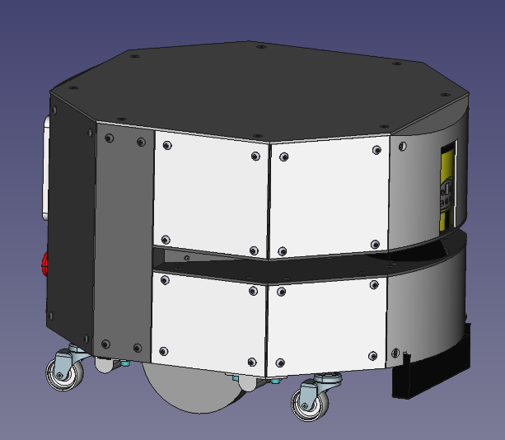

The vehicle has been designed as a functional prototype for professional use.

The robot has differential drive with the centre of the robot being coincident with the differential turning point.

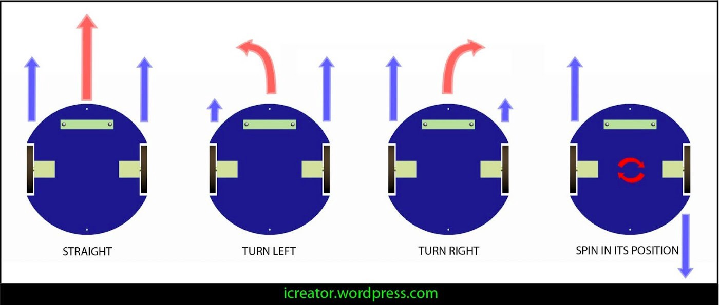

The robot has a hexagonal plant with an almost 33cm height and 48cm diameter (considering the surrounding circle)

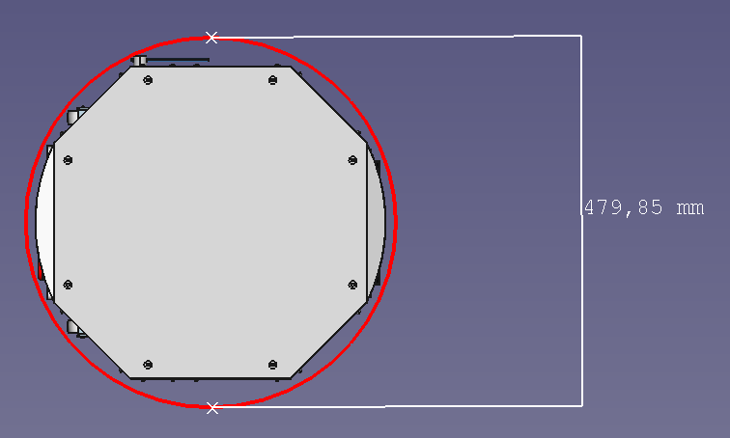 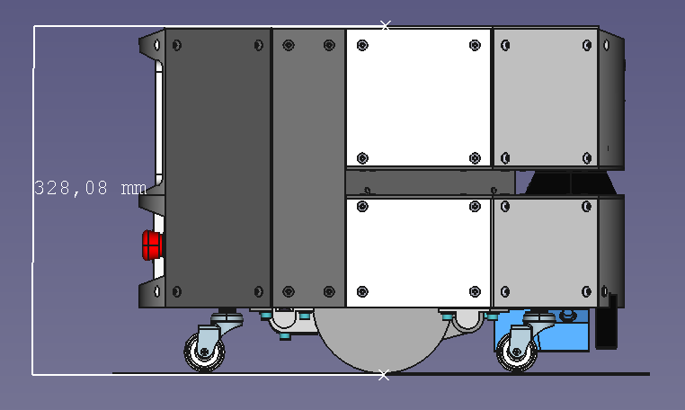

As prototype it has several 3D PLA printed parts. Some of them, specially brackets are easy to replace by steel parts available in the market. Other, like the front and back of the robot are not easy to replace.

There are several documents available with full details on BOM, Parts manufacturing and Assembly:

* AMR - Parts Manufacturing v1.pdf: Includes details on the manufacturing of parts.
* AMR - Assembly - Mechanical v1.pdf: Includes details on how to assemble the robot
* BOM AMR v2.xlsx: Includes the Bill of Materials of the robot

## Chassis

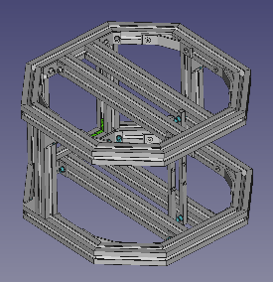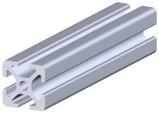

The Chassis is made mainly of aluminium alloy 30x30 beams like the one at the right. These parts are very robust and allow the use of fast connecting brackets.

As mentioned, all these connecting brackets have been made in PLA 3D printer in order to reduce cost of the prototype, but most of them are easy to replace with OEM brackets (mentioned in BOM)

One of the advantages of using this kind of beams is to use them to attach many things without the need of other supporting materials. Next figures show where devices are installed.

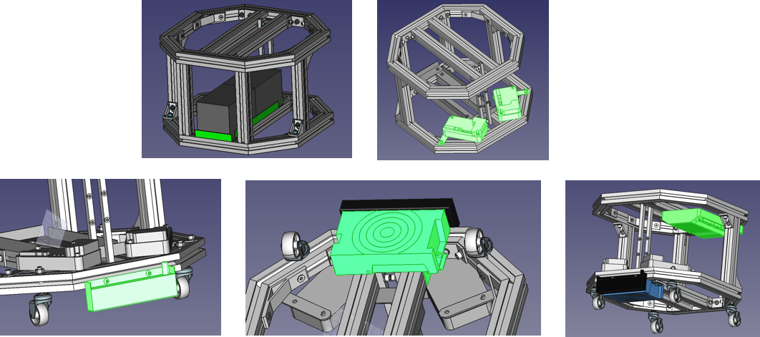

## Driving System

The Driving system is composed of the following elements:

* **Drives**: Gives power and speed control to the motors
* **Motors + Encoders**: Move the wheels
* **Wheels**: Caster wheels to support the weight of the robot and tractor wheels to move the vehicle.
* **Damping system**: Allows a correct adaptation of the tractor wheels if there are small defects on the floor
* **Clutch system**: Allows moving up the tractor part so the robot could be moved manually (pushing it)

### Drives

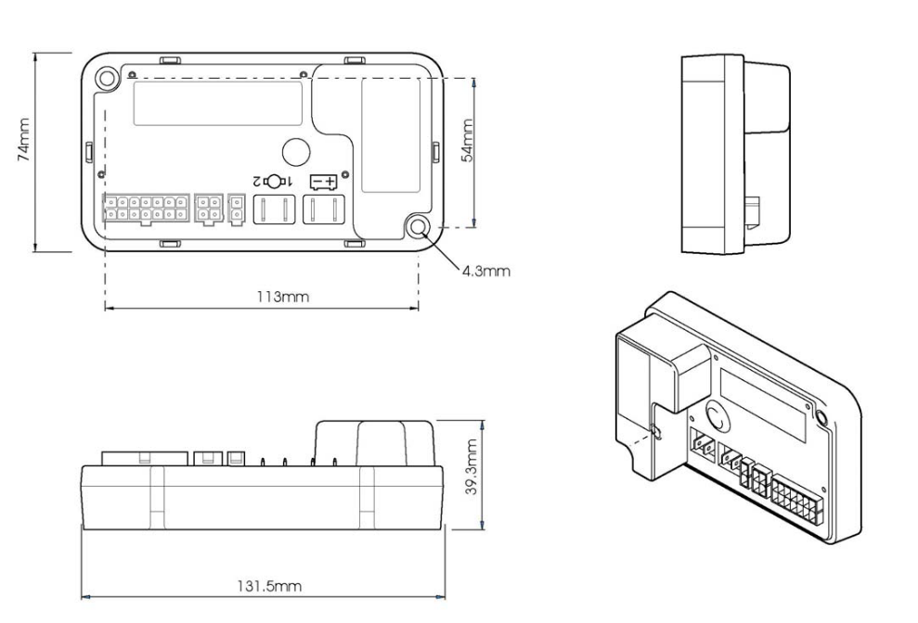

The Drives used are model D51400.01 from PG Drives.

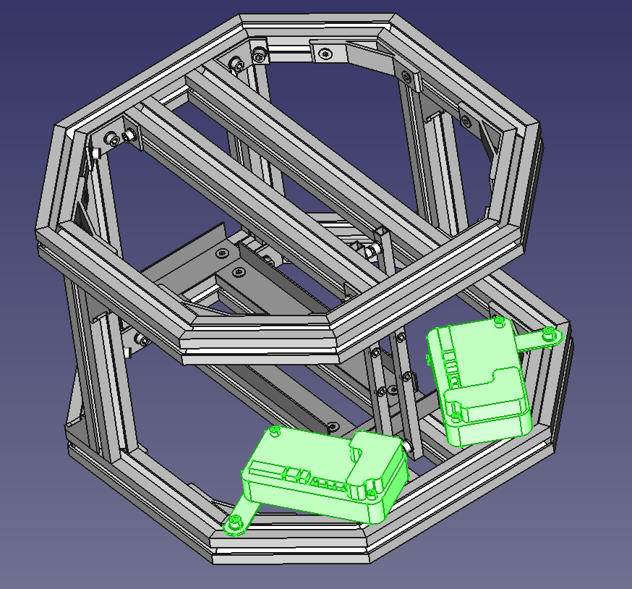

### Motors + Encoders

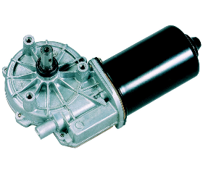

The motors used are model Valeo 0278AL and 0278AR for left and right. Below are their characteristics:

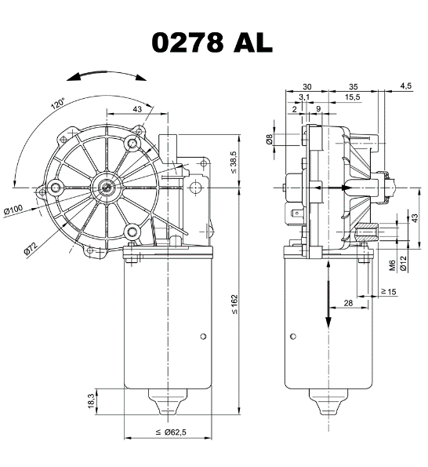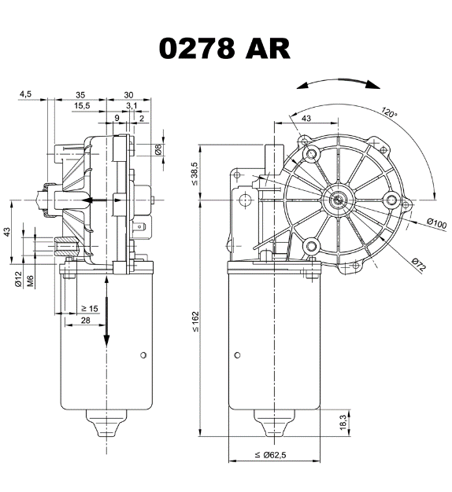

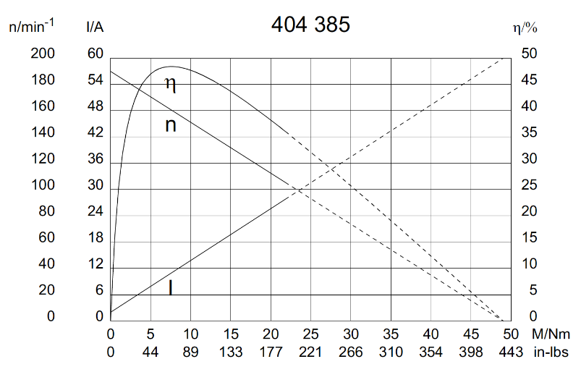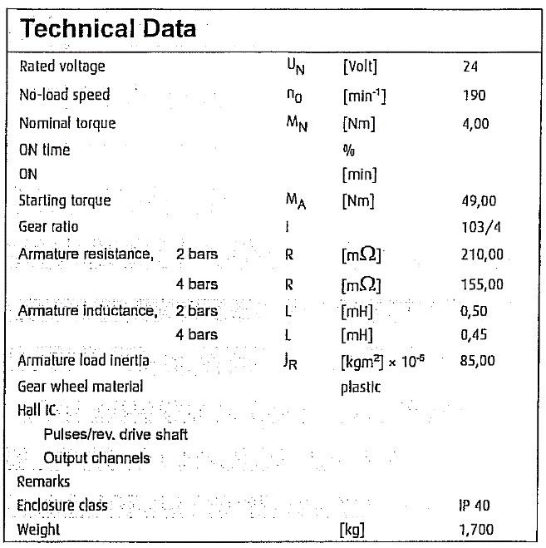

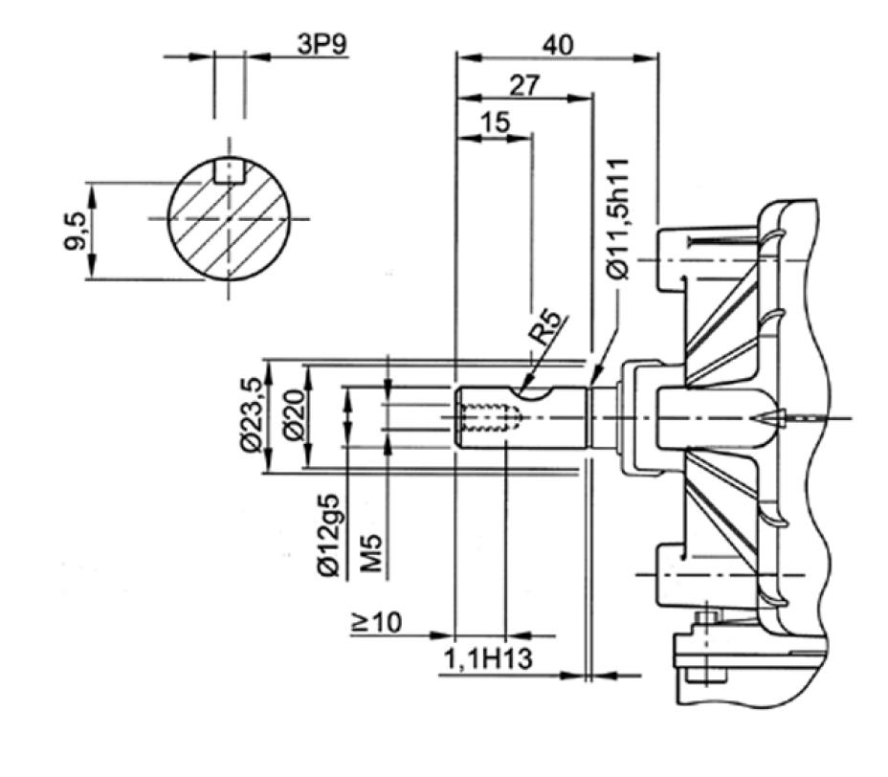

Shaft details at the left. Diameter: 12mm, Length: 27mm, Screw: M5

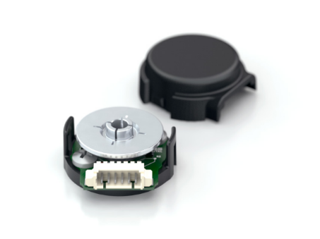

The encoders used are US Digital E4P, with the following mechanical characteristics:

* Minimum shaft length of .375 in.
* Fits shaft diameters of .079 in. to .250 in.
* Accepts +/-.020 in. Axial shaft play
* Off-axis mounting tolerance of .010 in.

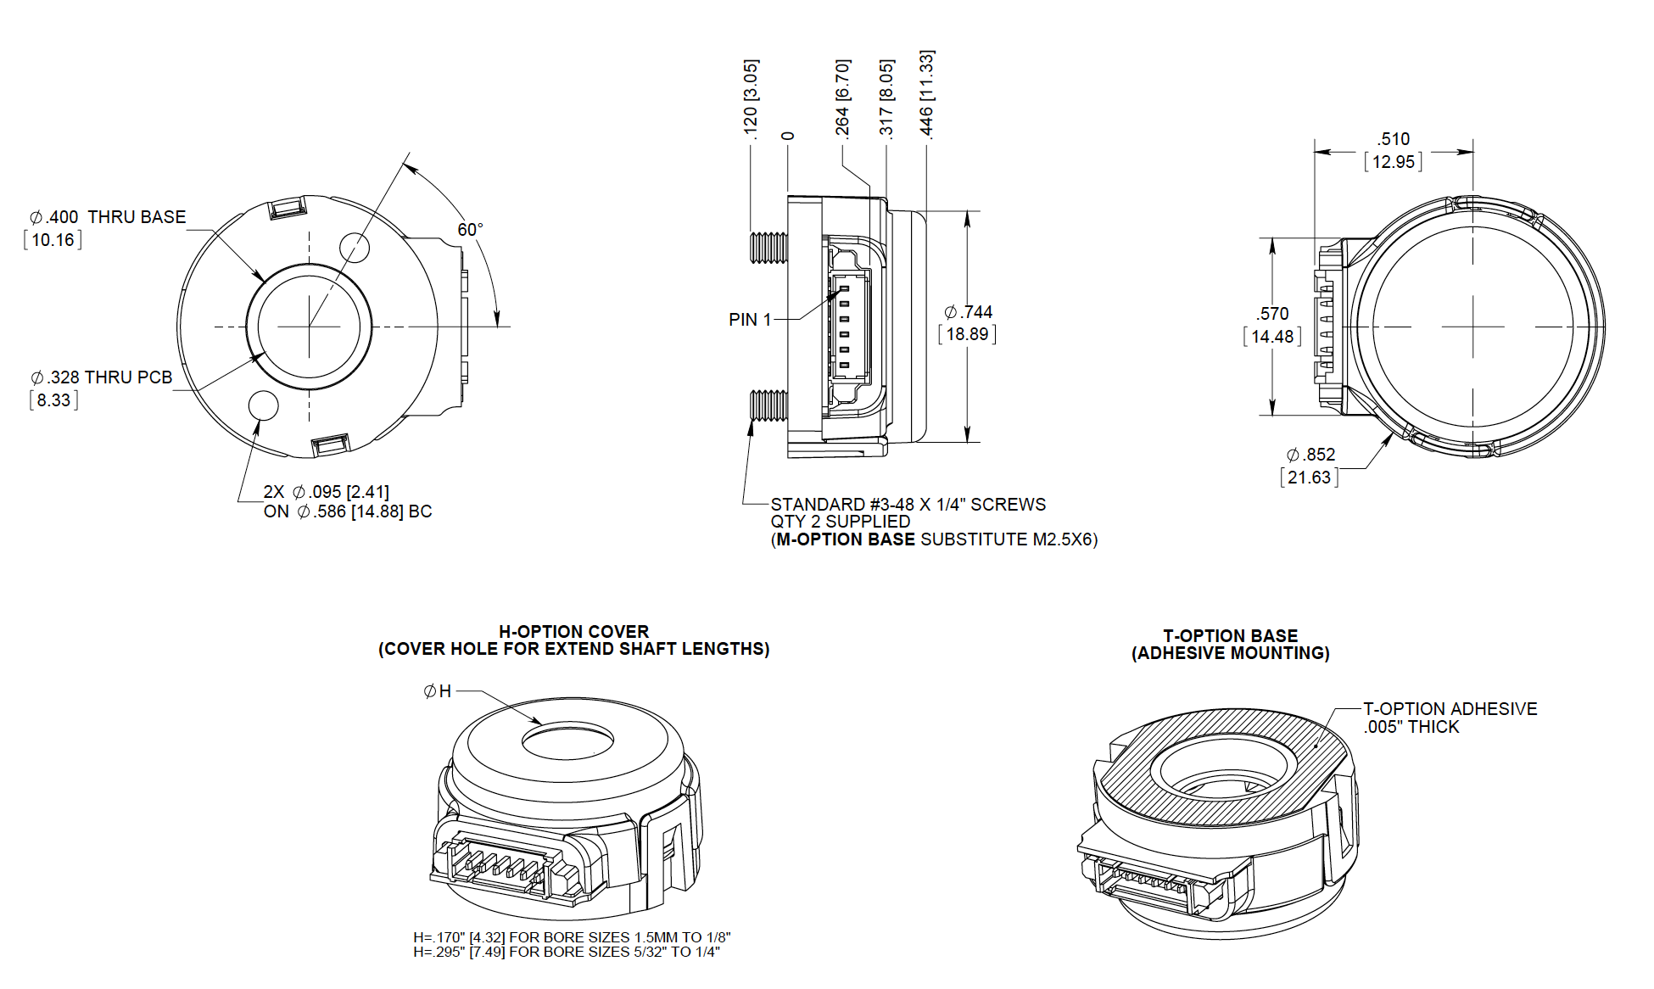

The E4P miniature encoder base provides mounting holes for two #3-48, length 1/4" or two M2.5x.45mm, length 6mm screws on a .586" bolt circle. When mounting holes are not available, a pre-applied transfer adhesive (with peel-off backing) is available for "stick-on" mounting.

The E4P version utilizes a push-on encoder disk which accepts shaft diameters of 2mm to .250".

### Wheels

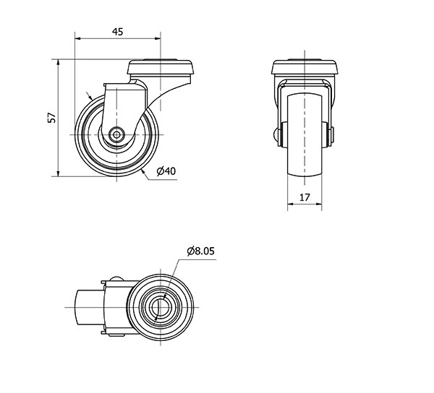

There are two kind of wheels: caster wheels and tractor wheels.

**Caster wheels** are used to support the weight of the robot. The model used is ALEX SERIES B-BP 3-0006. His wheel supports a maximum of 22Kg, therefore, as the robot use four, the set of wheels may support up to 88kg (Weight of the robot + additional payload)

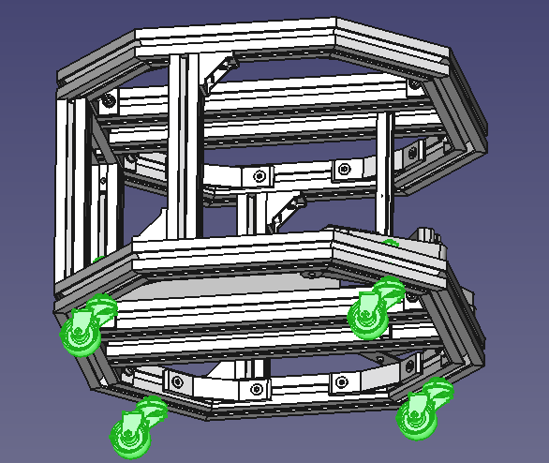

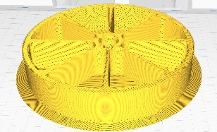**Tractor wheels** are made of PLA, reinforced in the axel connection with a metal piece and covered with a rubber band to ensure adherence to the floor. Wheels size is 130mm diameter (about 5”) and 25mm wide. Axel diameter is 12mm.

These wheels may be replaced by OEM wheels that are of same diameters and equal or less width. The absolute maximum limits are: Diameter: 125 to 130mm, width: 20 to 27mm

Alternatives:

* <https://www.ruedas-industriales-outlet.es/ruedas-fija-de-institucionales-a2-125.html>
* <https://es.aliexpress.com/item/4000126849143.html?channel=twinner>
* <https://es.aliexpress.com/item/4000558909487.html?channel=twinner>

Alternative wheel (125mm diameter, 27 mm width): Alex series 310-310. It is part of a caster wheel that should be disassembled. <https://www.alex.es/buscador?q=310-310>

Supplier: <https://maorferreteria.es/producto/533797/260202/serie-310-310-giratorio-agujero-pasante-sin-freno>

### Damping system

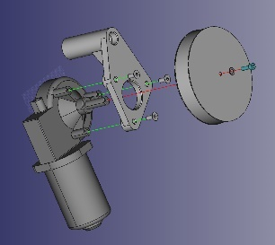

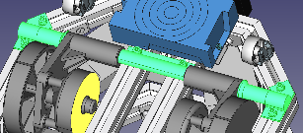Damping system allows a correct adaptation of the tractor wheels if there are small defects on the floor. The full block wheels + motor + encoders balance around an axel using a 3D printed adapter, shown in the image at the right, just between the motor and wheel.

This rotation around a balancing axel results on the wheel moving up or down on the floor.

The dumping system is supported on a common spring between the motor and the chassis (Shown below)

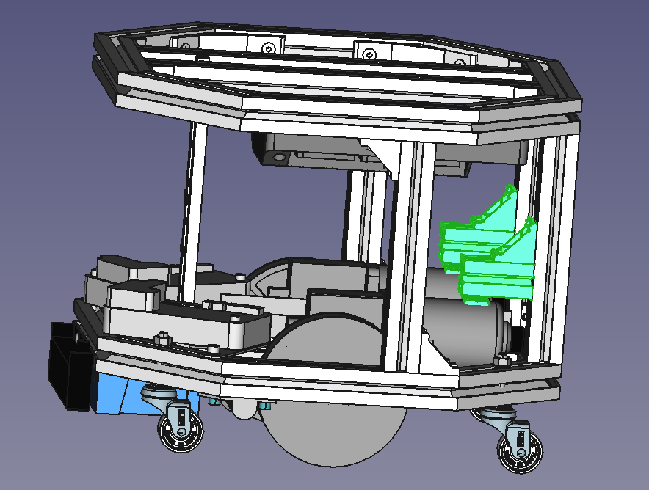 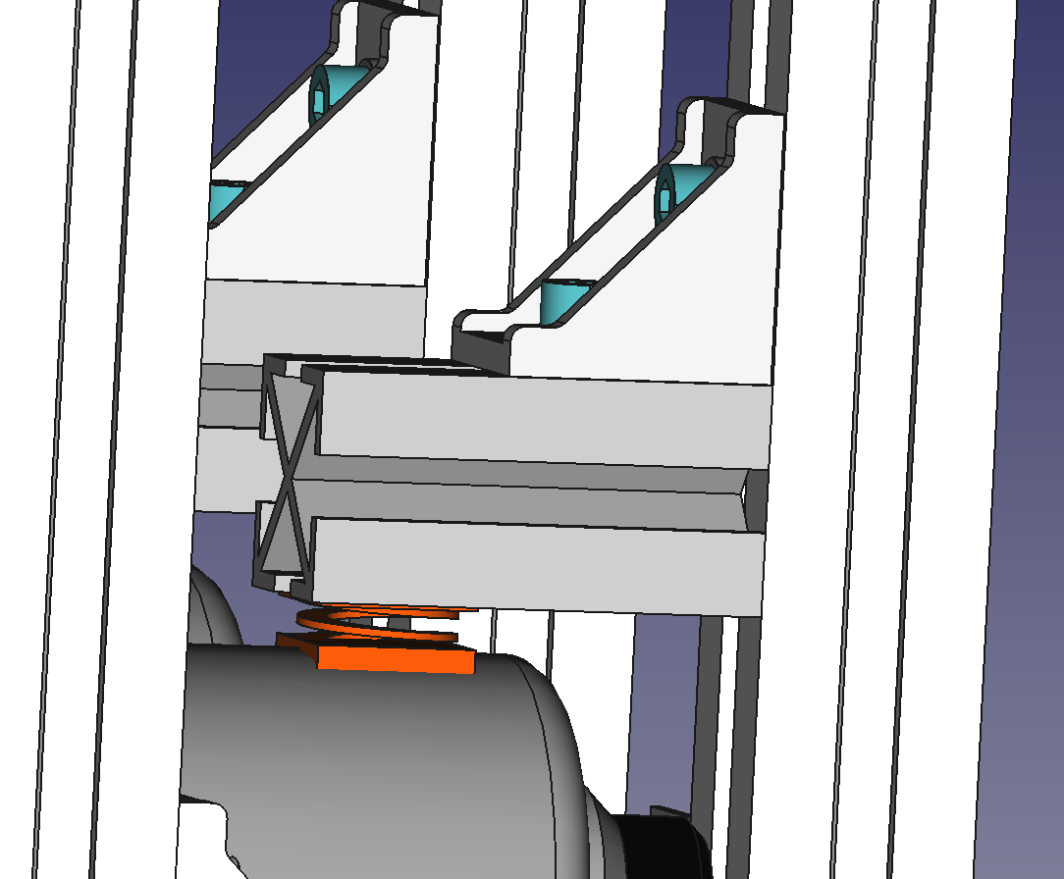 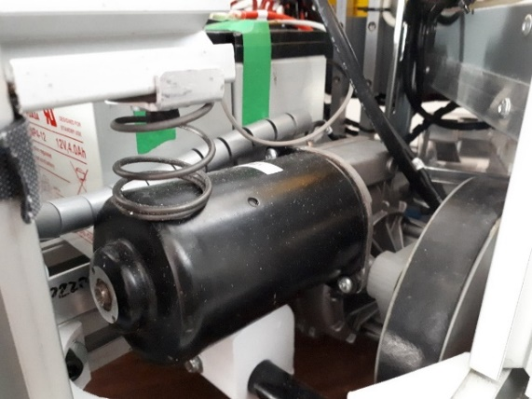

### Clutch system

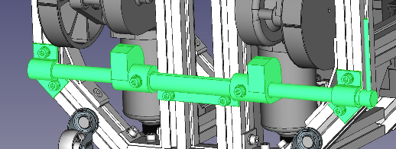The Clutch system allows moving up the tractor part, so the robot could be moved manually (pushing it). The system is activated by a lever, that rotates a sort of camshaft that pushes the motors against the springs, therefore moving the block motor+wheel around the balancing axel mentioned in de Damping system above and lifting the wheels from the floor.

## Safety System

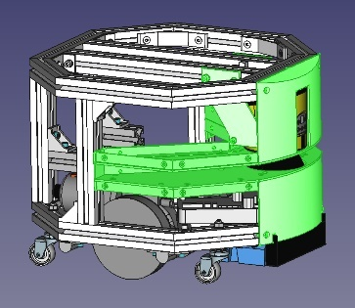The Safety System is composed of a Safety Lidar, a Safety PLC (FLEXY soft) and a Safety Stop Button.

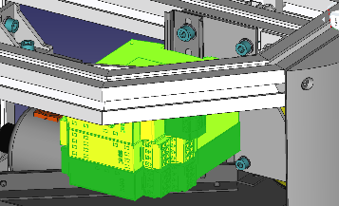The safety lidar is anchored to the chassis by two brackets at both sides. The Lidar produces a narrow beam of 270 degree. It has been designed a cover that protects de robot from exterior but also allows the beam to cover the 270 degrees.

The safety PLC is anchored via a DIN rail located at the right of the robot, just over the beam cover.

The Emergency Stop Button is located at the back of the robot

## PinHook System

It has been added a system with a lifting bar (Pin) to act as a hooking system for external trolleys. This system is using a linear actuator and is able to lift the Pin up to 30mm. It is located exactly in the centre of the top cover.

|  |  |  |
| --- | --- | --- |
|  |  |  |

The Pinhook has been designed to allow deformations of the casing, so if the Pin is pushed with a lateral force it may damage the structure of the linear actuator. In order to prevent it, the linear actuator could balance some degrees.

The casing also holds a magnetic sensor to identify when the Pin is fully contracted.

The pin is made of aluminium and has a permanent magnet inside.

Falta añadir que exista algún modo de evitar la rotación del carro

## Control System

### Low Level Controller (LLC)

LLC is the device that controls the Low-Level functionalities of the AMR. To see more details, go the the sw design section.

LLC is included in a 3D-print designed box (*LLC_Box_v4.FCStd Freecad file*). The design includes two parts called bottom (that supports all electronics) and cover, that supports a two-buttons membrane keyboard and the connectors.

The box is assembled as shown in the following pictures.

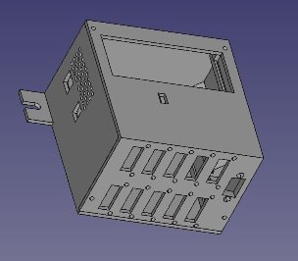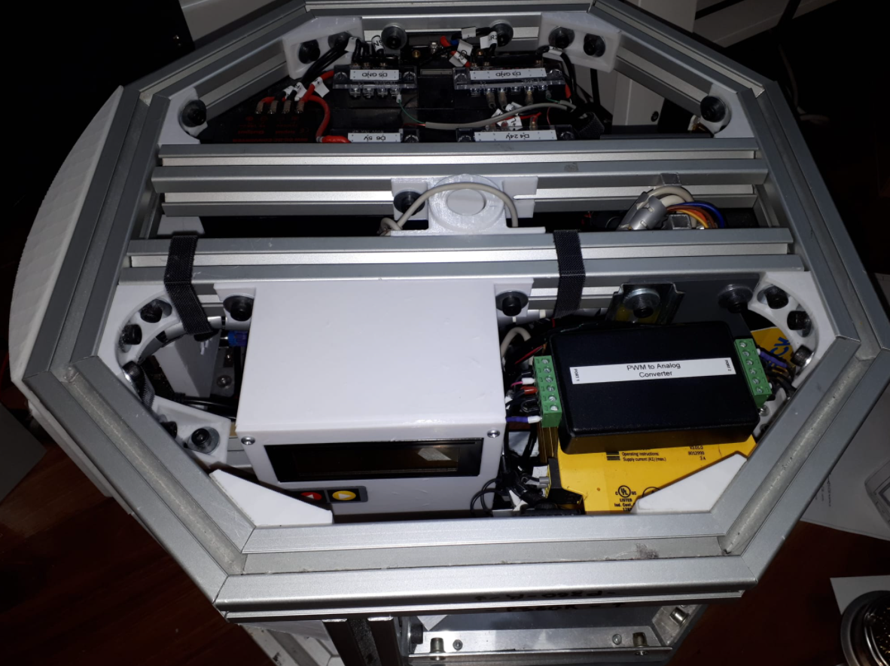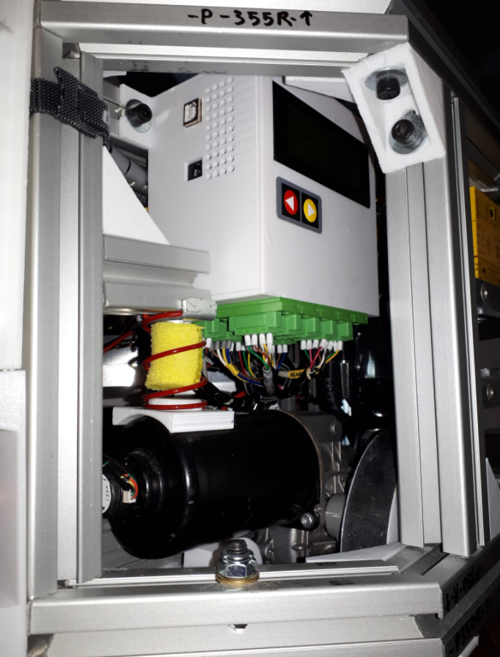

### High Level Controller (HLC)

HLC is the device that controls the High-Level functionalities. For more details on such functionalities, go to the SW design section. The HLC includes an interactive 7 inches screen. The HLC is supported on a 2 parts 3D-Printed cover. One of these parts is shown in the following section and the other part is just a back cover of the electronic parts.

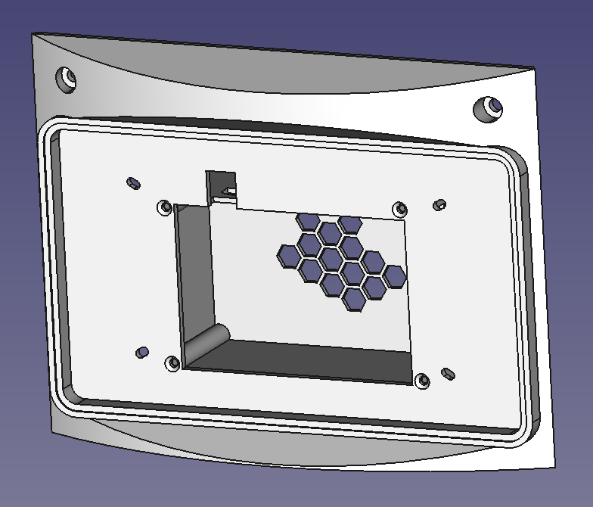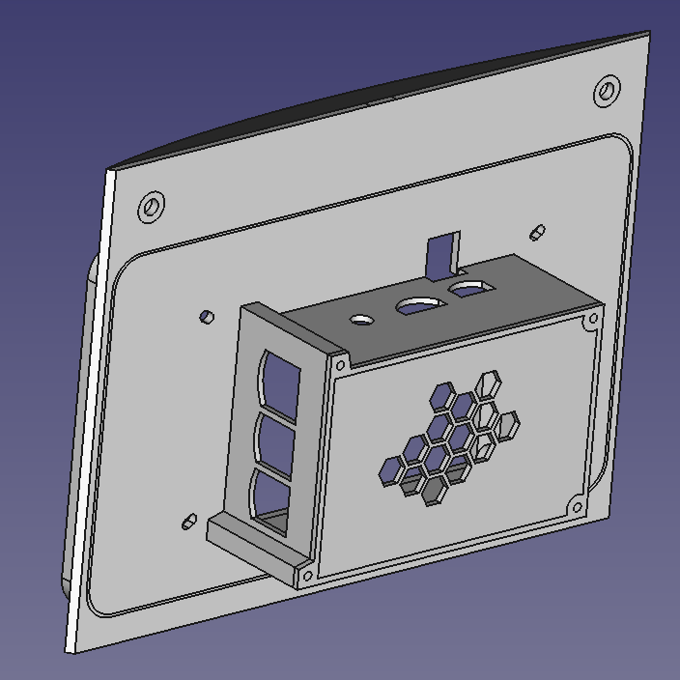

## External Covers

The robot is covered at the top and sides to protect the inside and give a nice aspect to the product.

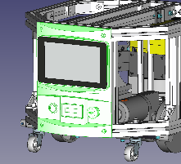Front and back covers are made out of 3D printed PLA parts, while all the rest of covers are made of 3mm PVC panels of white and grey colours.

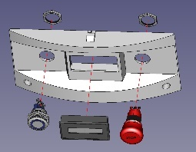Front cover protects the Safety Lidar and front bottom of the robot.

Back cover supports the HMI display and onboard PC as well as the voltmeter, safety stop button and general push button. Batteries could be replaced by releasing this cover.

The top and side covers have a reference written at their back side. This reference is also written on the chassis positions so it is easier to put each cover in its correct position.

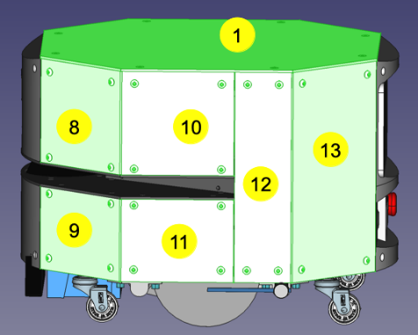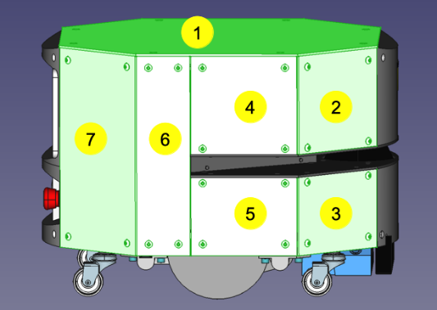

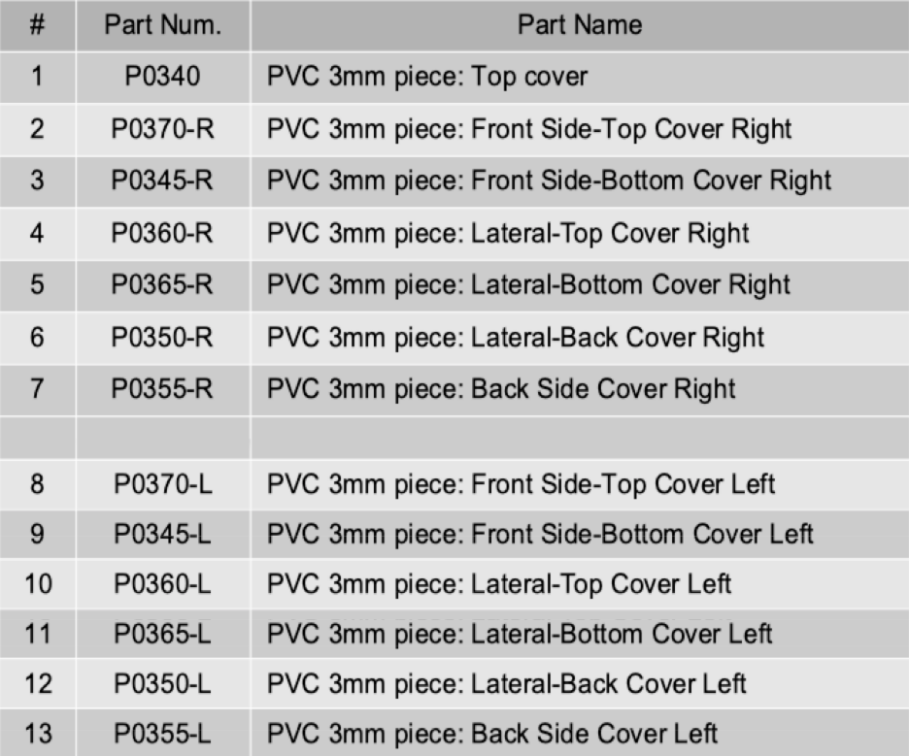

# Electrical Design

The Hardware architecture of the system is as follows:

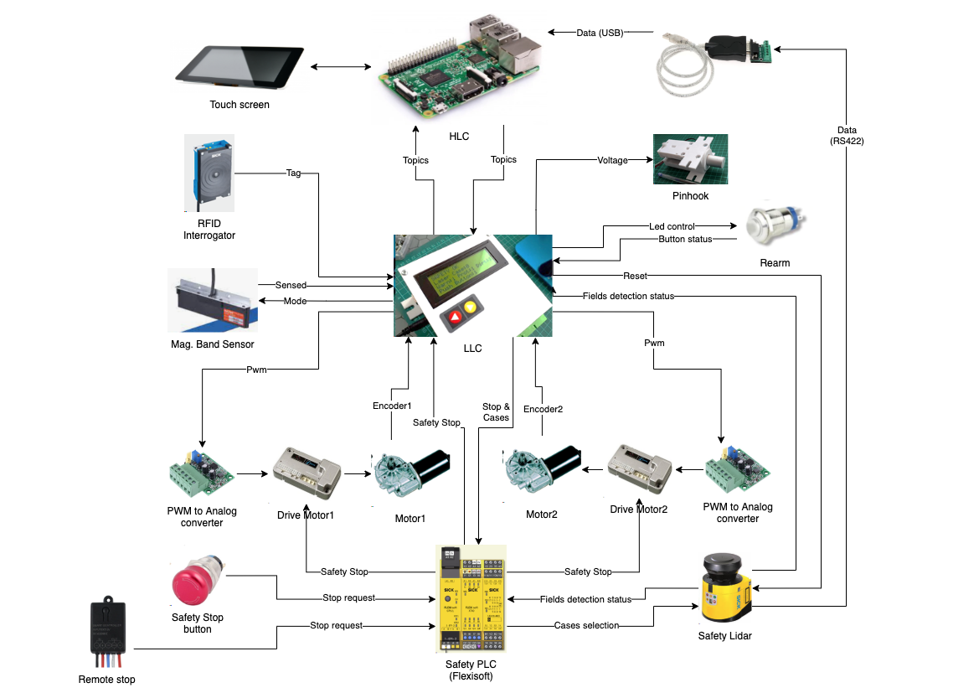

Let us describe the different components of the hardware:

## Power system

### Batteries

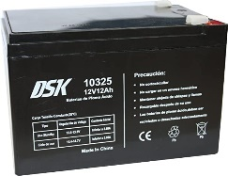

The robot is powered by a couple of 12v lead acid batteries connected in series, getting as a result 24v. The space for the batteries has been designed for two batteries of model DSK 10325, 12v, 12Ah, 15.1 x 9.8 x 9.9 cm; 3.18 kg

### Batteries status measure

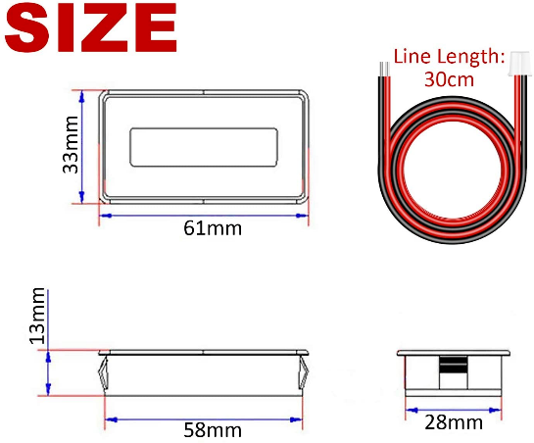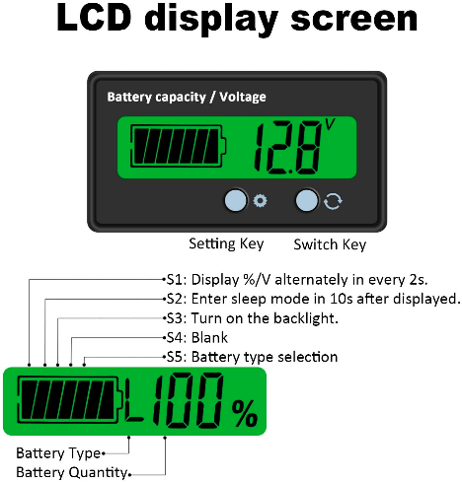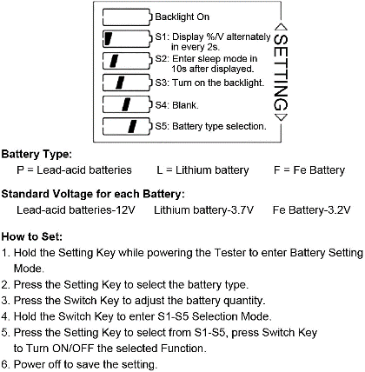Status of battery is measured with a voltage level display. This display shows the percentage of battery available, but this is really just a voltmeter that converts from voltage to percentage. Therefore, if the battery is not providing much current (vehicle stopped), the percentage may be reliable, but if the robot is moving (higher current draw), the voltage of the battery will go down due to its internal resistance and the display may show unreliable information. Characteristics of this device are:

* Voltage range: 6 to 63v dc, adjustable to 12v, 24v, 36, 48v to measure different types of batteries
* Two modes display: battery symbol + percentage or battery symbol + voltage
* *Setting key* with functions: Select battery type, battery voltage, sleep mode, background light on/off
* *Switch Key* to change between volts value, percentage value and switch off/on
* Inverse polarity protection

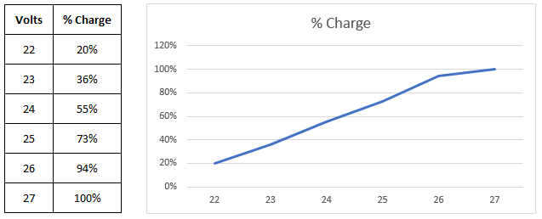

This device is connected to the ***Batt distributor*** (we will see later)

As we will see later, in Drives section, the led of drive status also could warn on status of battery.

### Battery Charging

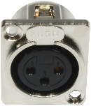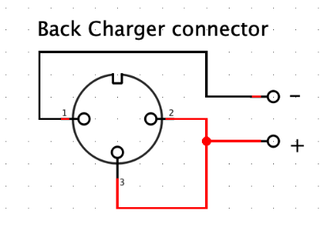There is an XLR connector at the back of the robot. This connector allows charging the batteries. There is a relay between this connector and the batteries that is normally closed. To open it, it is necessary to activate it applying a positive voltage on pin 3. Pin 1 is the negative of the charger and pin 2 is the positive of the charger. Therefor a simple way of connecting the charger as shown in the scheme. It is also possible to connect to this point a 24v power supply to keep the robot running during hours while programming, testing,..

There is an option to install another point of charging at the front of the robot for contact charging.

The battery charger used should be adequate for 24v lead acid batteries. The one used has recovery function too and is shown in the picture:

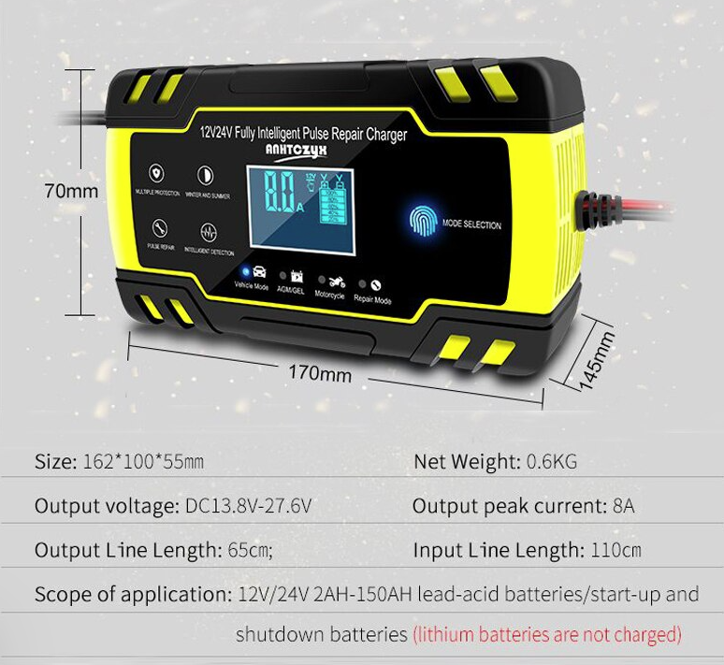

### Power distribution

There is a power distribution system in four levels:

* ***Batt distributor***: Distribute the power from the battery directly
* ***24v regulated distributor***: Distribute de power coming from a 24v DCDC regulator
* ***12v regulated distributor***: Distributes de power coming from a 12v DCDC regulator
* ***5v regulated distributor***: Distribute the power coming from a 5v DCDC regulator

The power from the battery goes via a power switch that is at the bottom left of the robot to a fuse box. This fuse box has 4 fuses for each of the distributors mentioned above.

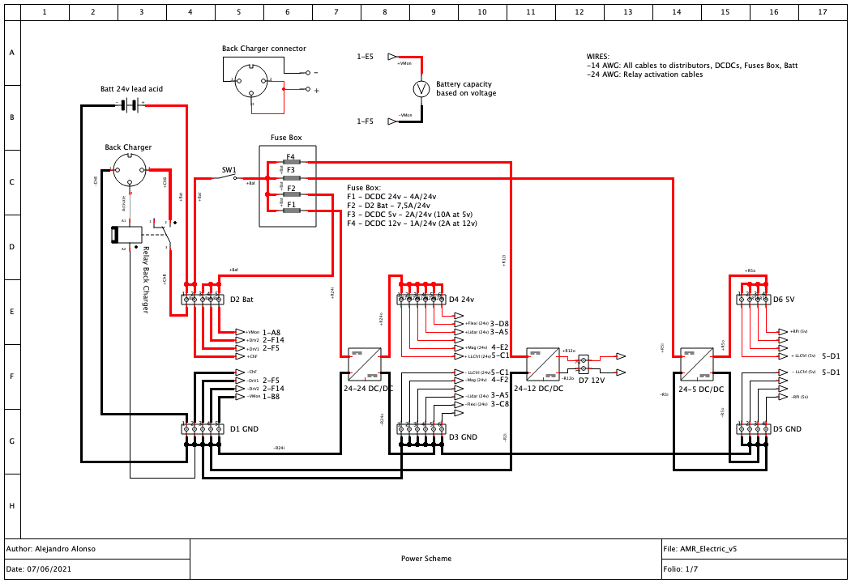

#### Batt distribution

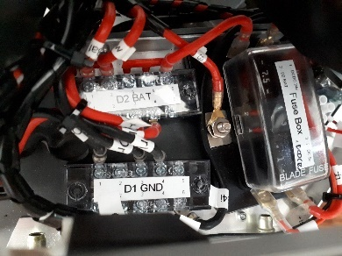

**Fuse number 2** is rated 7.5A/24v and gives power to the ***Batt distributor*** (D1 GND, D2 Bat). This distributor gives power to those elements that requires high current and can work with a wide voltage range, considering this voltage will change with the battery charge status. The devices connected are:

* Drive 1: As we will see later, this Drive controls the speed of the right motor
* Drive 2: As we will see later, this Drive controls the speed of the left motor

#### 24v regulated distribution

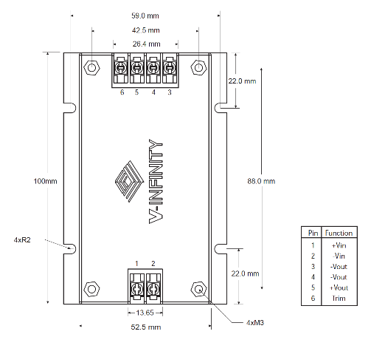**Fuse number 1** is rated 4A/24v and gives power to the input of a 24-24 DCDC regulator, and the output of this regulator gives power to the ***24v regulated distributor***. The DCDC regulator used for this purpose is a V-INFINITY VDZ200-D24-S24 with the following characteristics:

* Input range: 18-36v
* 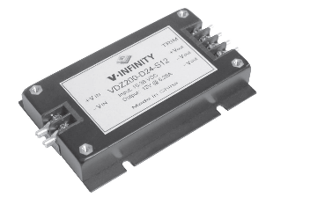Output regulated voltage: 24v
* Output current: 4.16 A
* Output power: 100W
* Ripple & Noise: 200 (mVpp)
* Typical efficiency: 88%
* Switching frequency: 180kHz (Typical)
* Maximum temperature: 85 celsius degrees

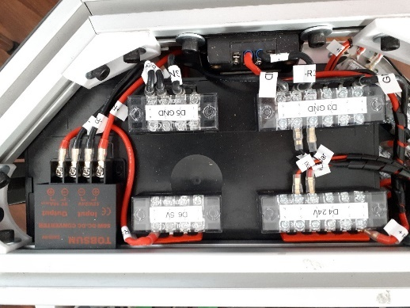***24v regulated distributor*** (D3 GNC, D4 24v) gives power to several electronic devices rated for 24 volts. Between them:

* Safety Lidar
* Safety PLC
* Control PLC
* Magnetic band sensor
* RFID sensor

#### 12v regulated distribution

**Fuse number 4** is rated 1A/24v and gives power to the input of a 24-12 DCDC regulator, and the output of this regulator gives power to the ***12v regulated distributor***. The DCDC regulator used for this purpose is a Dimension Engineering DE-SWADJ with the following characteristics:

* Input range: 3-30v
* 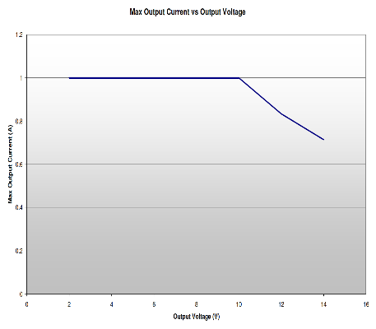Output regulated voltage: adjustable via 25-turn potentiometer between 1,25v and 13v, but adjusted to 12v in this case
* 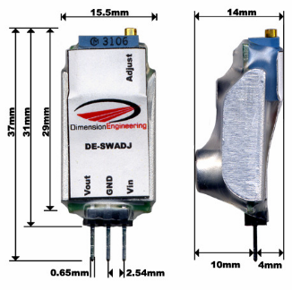Output current: 1 A
* Output power: 10W
* Ripple: Less than 2% of output
* Typical efficiency: 92%
* Switching frequency: 270kHz (Typical)
* Maximum temperature: 70 Celsius degrees

***12v regulated distributor*** is just a small terminal block located at the right of the fuse box. At this moment just powers the LED strips at the bottom of the robot.

#### 5v regulated distribution

**Fuse number 3** is rated 2A/24v and gives power to the input of a 24-5 DCDC regulator, and the output of this regulator gives power to the ***5v regulated distributor***. The DCDC regulator used for this purpose is a TOBSUN EA50-5V with the following characteristics:

* 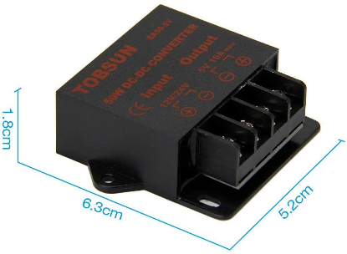Input range: 8-40v
* Output regulated voltage: 5v
* Output current: 10 A max
* Output power: 50W
* Ripple: 200 (mVpp)
* Typical efficiency: 90%
* Maximum temperature: 80 Celsius degrees
* Protection for overvoltage, overtemperature, overcurrent, short-circuits

***5v regulated distributor*** (D5 GNC, D6 5v) gives power to several electronic devices rated for 5 volts. Between them:

* Raspberry Pi + touch screen
* Encoders

## Driving system

Driving System is composed of the following elements:

* **Motors**, that produce the movement
* **Encoders**, that give feedback on the speed of the motors to the control system
* **Drives**, that give power to the motors based on variable input voltage
* **PWM** **to Voltage converter**, which converts from PWM signals from the control system to voltage levels for the drives

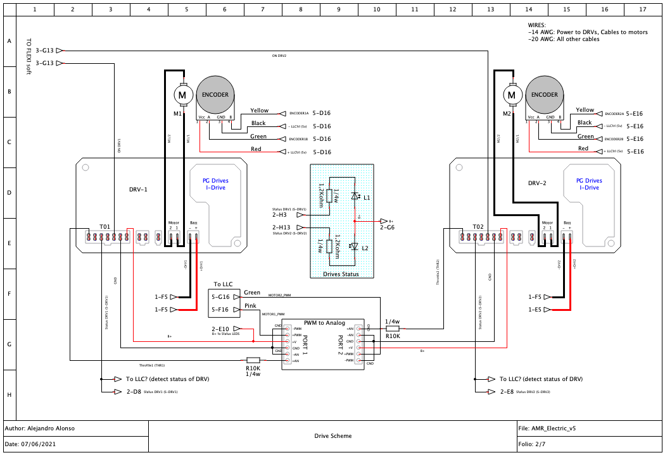

### Motors

The motors used are model Valeo 0278AL and 0278AR for left and right. Below are their characteristics:





### Encoders

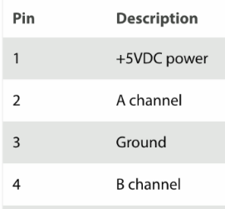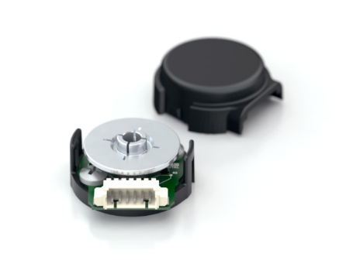

The encoders used are US Digital E4P, with the following characteristics:

* 100 to 360 cycles per revolution (CPR)
* 400 to 1,440 pulses per revolution (PPR)
* Single +5V supply
* 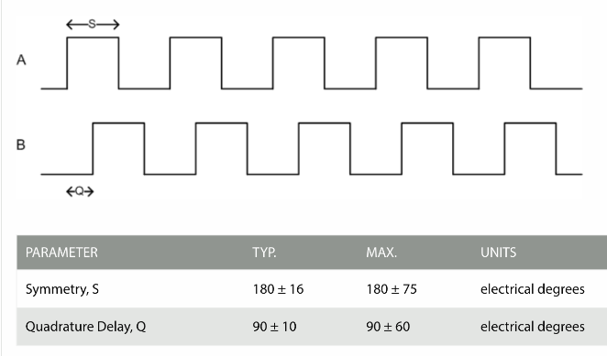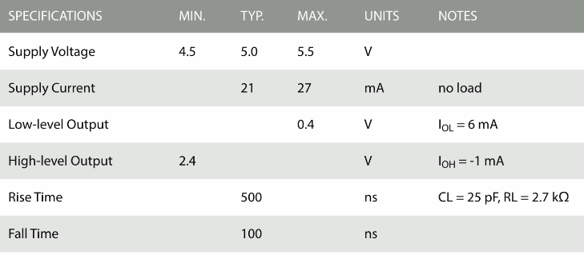Operating Temperature: -20 to 100 Centigrade Degree

Micro mating connector shell (Molex# 51021-0400) and 4 pins for 26-28 AWG wires (Molex # 50079-8100).

### Drives

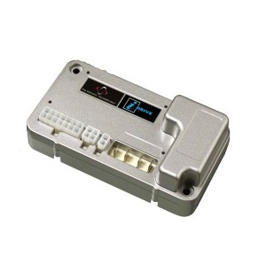

The Drives used are model D51400.01 from PG Drives with the following characteristics:

* SUPPLY VOLTAGE: 24Vdc
* OPERATING VOLTAGE: 16-30Vdc
* PEAK VOLTAGE: 36Vdc
* REVERSE BATTERY VOLTAGE: 40Vdc
* OUTPUT CURRENT: 45A
* PWM FREQUENCY: 20kHz ± 1%

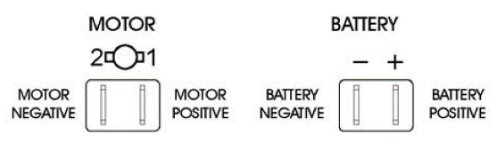

The drive has the following connectors:

**Motor and battery.** Both are of Faston type. Cables used are 14 AWG

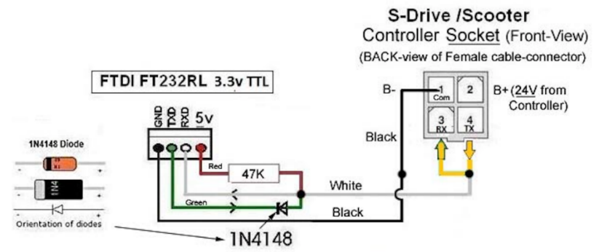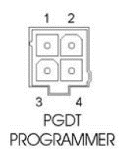**PGDT Programmer**. Used to modify the parameters from the drive. Use the following cable to connect this connector to the PC with the programmer installed, and refer to the programming guide to see what parameters are configurable.

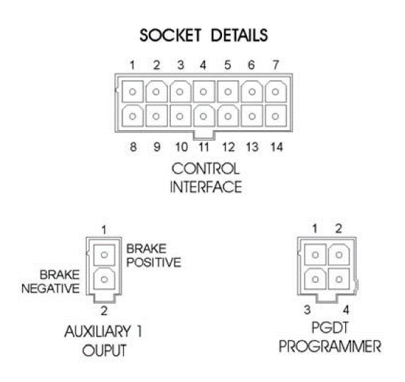

**Auxiliary 1 Output**. Not used in this AMR

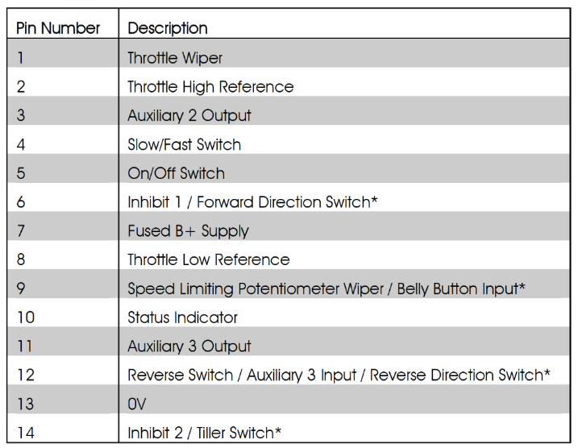**Control Interface**. This connector includes 14 pins. We use only 5 of them, although in the following figure we mentioned the purpose of all of them.

As mentioned, we use only 5 of them:

* **Pin 13 – 0v**. It is internally connected to de GND or negative pole from the power supply (Battery connector), so we use it to provide ground to the next element, that is the PWM to Analog converter
* **Pin 7 – B+**. This is internally connected to the positive pole of the power supply (Battery connector) providing 24v. We use it to provide positive power supply to the next element, that is the PWM to Analog converter
* **Pin 5 – On/Off Switch**. This is an input to activate or deactivate the Drive function. 0v deactivate the drive and 24v activate the drive. We connect this line to the safety PLC (Safety system) so we could stop immediately the vehicle if there is a safety compromise.
* 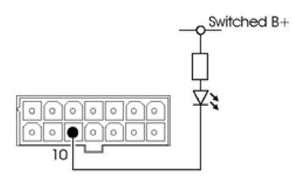**Pin 1 – Throttle**. This is an analogue input (0-5v) that stablish the speed and rotational direction of the motor. The motor is stopped at 2.5v. Increasing the voltage increase the speed in one direction. Decreasing the voltage below 2.5v increase the speed in the opposite direction. This signal comes from the PWM to Voltage converter output.   
  Something to consider is that 5v in this input means maximum speed in the forward direction of the AMR and 0v in this input means maximum speed in the backwards direction of the AMR. Therefore, not giving any voltage would be considered as 0V. Take care with that. Do not activate the Pin 5 unless you are sure you are providing the adequate Throttle value.  
  As specified in the technical manual of the drive, there is a 10k resistor between this input and the provider of the throttle voltage (the PWM to Voltage converter)
* **Pin 10 – Status indicator**. This output pin is used to get feedback of the status via a led diode, connected to B+ with a 1,2Kohm resistor.

The status indicators:

There is one status indicator per drive, so two in the AMR, located at the right side of the vehicle, near the Safety PLC.

The Leds behaviour could explain the situation of the drives as follows:

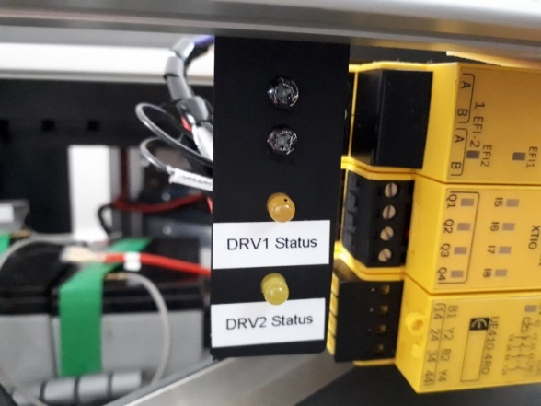

* **Status Indicator Steady** 🡪 This indicates that all is well.
* **Status Indicator Flashes Slowly** 🡪 The controller is functioning correctly, but you should charge the batteries as soon as possible. Do not operate the machine if the battery is nearly discharged.
* **Status Indicator Blinks On Every 5 Seconds** 🡪 The controller has entered Sleep Mode. Recycle the power to reset.
* **Status Indicator Flashes Rapidly** (even with throttle released) 🡪 The controller safety circuits have operated and the controller has been prevented from moving the machine. This indicates that there is a trip.

### PWM to Voltage converter

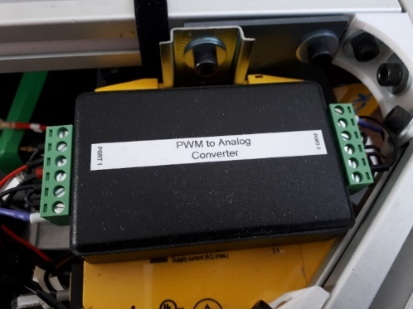PWM to Voltage Converter is a box used in the AGV, located over the safety PLC.

This box contains two independent PWM to voltage converters like the image below. Each of them converts from a PWM signal from the LLC and provides a voltage signal to a Drive.

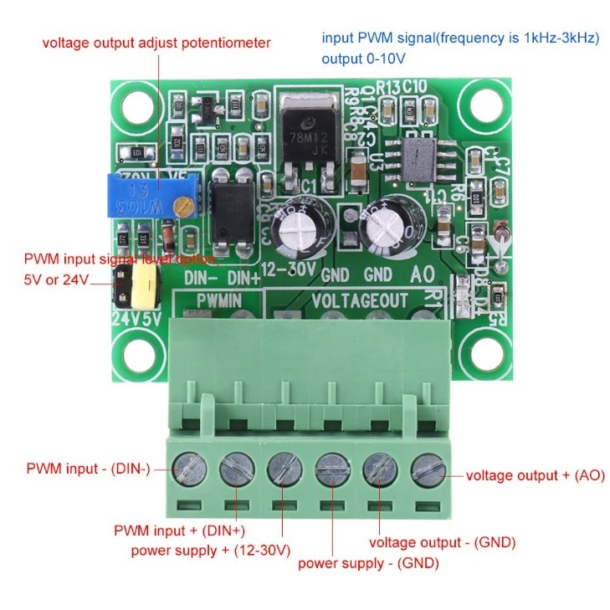

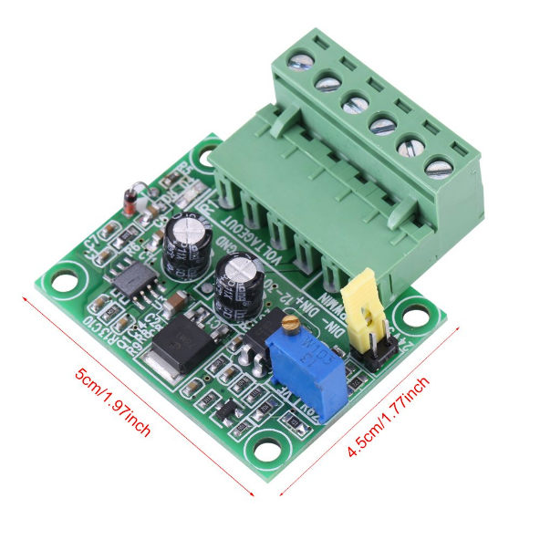

Characteristics:

* Power supply: 12 to 30v
* Valid PWM frequency input: Between 1KHz and 3KHz (Note: Really it works from a wider range, from 100hz to over 8Khz as tested at 50% duty)
* PWM input voltage: 5v or 24v. Should be set using the jumper for that purpose. For this specific application it has been set to 24v
* Maximum output voltage: Up to 10v, but could be adjusted using the multiturn blue potentiometer. For this specific application it has been set to 5v

These modules convert from a PWM signal of 24v peak to voltage, depending on the duty cycle of the PWM signal. A duty of 0% is converted to 0v while a duty of 100% is converted to 5v. As explained in the Drives section, a voltage of 2.5v means the motor is stopped, a voltage below it means the robot moves backwards and a voltage over 2.5v means the robot moves forward. The following table could clarify the relations between the different signals and effects:

|  |  |  |
| --- | --- | --- |
| Duty Cycle | Output voltage | Effect in motor |
| 0% | 0v | Maximum speed backwards |
| 50% | 2.5v | Motor stopped |
| 100% | 5v | Maximum speed forward |

**Therefore, consider the risk of not setting a PWM value at the LLC while activating the Drive. It would mean a maximum speed backwards of the motor (maximum torque)**

The system as it will be shown later in the Safety Part sets by default the off state of the drive, waiting for the LLC to release this condition after a PWM signal is applied, but there is no control on that.

An option for future improvements would be to incorporate an electronic circuit able to identify the absence of pulse. Following is an idea of a circuit that may solve that, taken from <https://unicrom.com/detector-ausencia-de-pulso-con-555/>

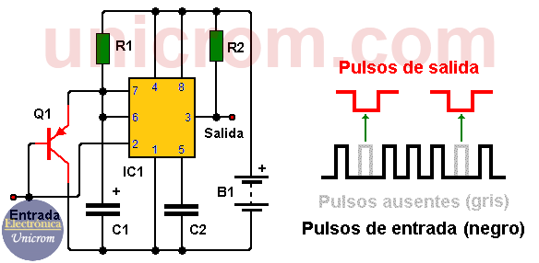 Components:

* IC1: 555 Timer
* Q1: PNP NTE159 transistor
* R1 = R2: 10K resistor
* C1: 47 uF electrolitic capacitor
* C2: 0.01uF capacitor

## Safety system

The safety system of the robot is composed of the following elements:

* **Safety Laser**: that detects the risk of collision
* **Safety emergency stop button**, that allows to stop immediately de robot
* **Safety PLC**, that consider signals coming from the previous two devices, and from other external elements and actuate on the Drives to immediately stop de robot if needed

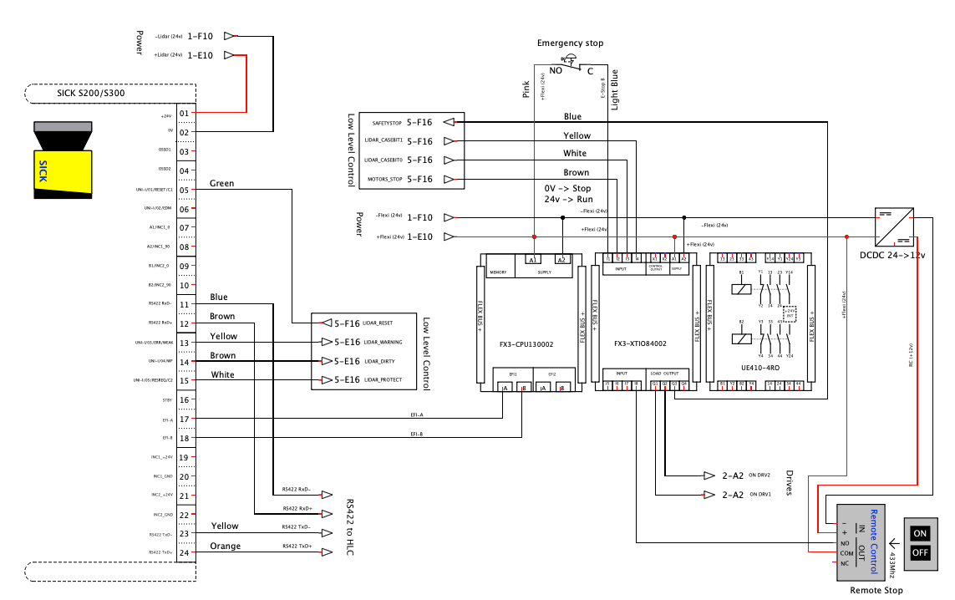

### Safety Laser

The installed laser is a Sick s300 Expert

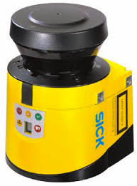Characteristics:

* Supply voltage Vs: 24 V DC (16.8 V DC ... 30 V DC)
* Power consumption : ≤ 0.33 A
* Enclosure rating: IP65 (EN 60529)
* Ambient operating temperature: –10 °C ... +50 °C
* Storage temperature: –25 °C ... +50 °C
* Protective field range: 3 m
* Warning field range: 8 m (at 15 % reflectivity)
* Distance measuring range: 30 m
* Type of field set: Triple field sets
* Number of field sets: 16
* Number of fields: 48
* Number of monitoring cases: 32
* Scanning angle: 270°
* Resolution (can be configured): 30 mm, 40 mm, 50 mm, 70 mm, 150 mm
* Angular resolution: 0.5°
* Response time: 80ms
* Protective field supplement: 100 mm
* Number of multiple samplings: 2 ... 16, configurable
* Delay of automatic reset: 2 s ... 60 s, configurable
* Integration in the control: Local inputs and outputs (I/O), EFI
* Data interface: RS-422. Transmission rate ≤ 500 kBaud

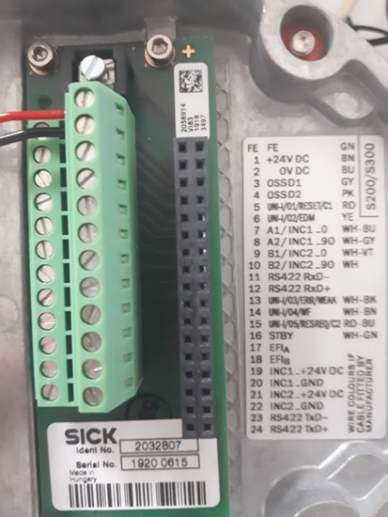

This device has 24 pins connector inside the base as shown in the picture. The pins used for this robot are the following:

|  |  |  |  |
| --- | --- | --- | --- |
| Pin | Reference | Function | Connection |
| 1 | +24v DC | 24v power | From regulated 24v |
| 2 | 0v DC | GND | From GND |
| 5 | UNI-I/01/RESET/C1 | Reset the device | Input |
| 11 | RS422 RxD- | Data Interface | To PC via RS422 to USB conv. |
| 12 | RS422 RxD+ | Data Interface | To PC via RS422 to USB conv. |
| 13 | UNI-I/03/ERR/WEAK | Dirty laser | Output |
| 14 | UNI-I/04/WF | Warning Field | Output |
| 15 | UNI-I | Protective Field | Output |
| 17 | EFI-A | EFI port | To FLEXI softsafety PLC |
| 18 | EFI-B | EFI port | To FLEXI softsafety PLC |
| 23 | RS422 TxD- | Data Interface | To PC via RS422 to USB conv. |
| 24 | RS422 TxD+ | Data Interface | To PC via RS422 to USB conv. |

EFI port allows the full control of the laser from the safety PLC

RS422 port (4 pins) allows sending laser readings to the PC for navigation purpose.

### Safety Emergency Stop

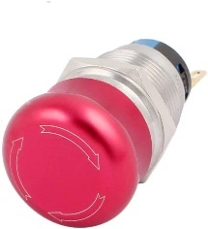The Emergency Stop Button allows stopping immediately de robot. It should be pushed only in emergency cases, as it stops the vehicle so instantly that may harm wheels over time.

The model used in this robot has a unique switch inside 1NO / 1NC (SPDT), 5A current.

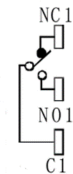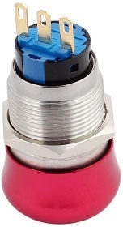When pushed it locks in such position. The connections are as follows:

* C (Common) is connected the Safety PLC signal E-Stop (Safety Switch)
* No (Normally open) is connected to 24v
* Nc (Normally closed) is left unconnected

Therefore, by default the FLEXI soft will get 24v in the Safety Switch input when if the button is pushed.

### Remote Emergency Stop

This is composed of 433Mhz receiver and an ON-OFF remote control

The device is powered at 12v by a Linear DCDC LM7812, that takes 24v as input. The COM is connected to 24v and NO is connected to I8 in the safety PLC. The device is configured in **Latching Mode** so when the OFF button is pushed, the internal relay is activated and the FlexySoft receives 24v in I8. If ON button is pushed, the relay is deactivated and the Flexysoft receives no signal in it´s I8 input. *Really this design is not the proper one. It should have been connected so NO is connected to 24v, NC to GND and COM to the I8 Flexysoft input. In that case that input always receives or 0v, or 24v, but leaving it open might be prone to noise input*.

The characteristics of the device are the following:

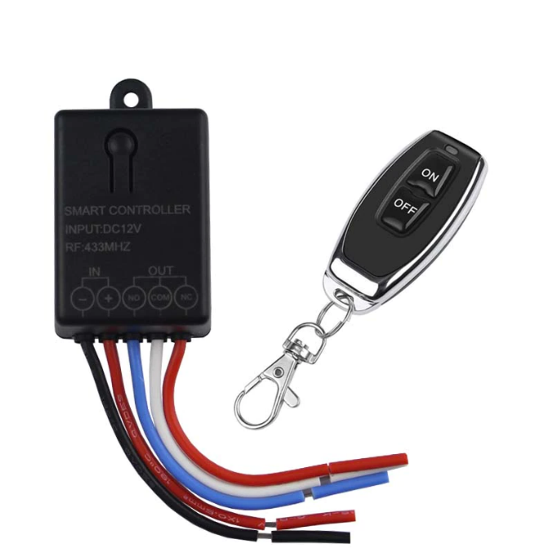Technical Data of Receiver:

* Input Power: DC10V-14V
* Standby Current: <5MA
* RF Frequency: 433M
* RF working mode: superheterodyne
* Receive sensitivity: >-97dbm
* Transmitting distance:>50m (open space)
* Decoding mode: MCU software decoding
* Remote storage: 20pcs
* Support remote type: EV1527 Learning code, Fixed code
* Working mode: Momentary, Toggle, Latching Time delay (5s ,10s ,15s,20s )，Automatic pull-in when power on
* Wiring type: fixed terminal
* Output Terminal: NO, NC , COM
* Dimension of PCB:36*26*17mm (L,W,H)

Wiring diagram 1:

* + : 12V + input ;
  + : GND - input;
* NO: Output, normal open;
* COM: Output, common;
* NC: Output, normal close.

Specifications of the Remote Control:

* Operating frequency: 433.92MHz
* Power by 3V Coin Cell Button Battery (Battery included),
* Material: PVC.
* Button: 2 buttons
* Size: 59mm x 28mm x 8mm;
* Operating voltage: 3V;
* Operating Current: 12mA
* Transmitting power: 10mw
* Modulation mode: ASK (AM).
* Encoding type: Learning.
* Transfer distance:50m (open space)

About Working mode:

* Momentary: Push the remote button, the relay connects, release the remote button, the relay dis-connects.
* Toggle: Push once the remote button, the relay connects, push twice the remote button, the relay dis-connects.
* Latching: Push the remote button A, the relay connects, push the remote button B, the relay dis-connect.
* Time delay mode: Push the remote-control button, the relay connects, from when release the remote button, after 5s or 10s or 15s or 20s, the relay disconnects automatically.
* Automatic energize when power on mode: when power supply, the relay connects.

Clearing the code:

* After push the receiver's learning button 9 times, the receiver Clear all the remote-control data in its memory.
* When the LED flashes for 5 few times, it indicates that the clear function is completed.
* (After cleared the code in the receiver, all the remote control must study from receiver once again to restart. ）

Receiver operating mode Settings

1. Learning the code :(momentary)

Push the learning key on the receiver once time, it comes into momentary setting mode. Wait for a moment, the LED will be on, it comes into learning state. Push the remote button, LED indicator on the receiver board will flash 3 times and then come off, learning successfully.

1. Learning the code: (Toggle)

Push the learning key on the receiver twice time, it comes into toggle setting mode Wait for a moment, the LED will be on, it comes into learning state. Push the remote button, LED indicator on the receiver board will flash 3 times and then come off, learning successfully.

1. Learning the code: (Latching)

Note: When you choose for latching mode, in order to learn more remote control, you need to learn two different buttons, the first time learnt is for “ON”, the second time learnt for “OFF”. For example: button A = ON, button B = OFF, Push the learning key on the receiver triple time, it comes into latching mode. Wait for a moment, the LED indicator on the receiver board will be on, Push the remote button A, LED flash for 3 times. Push the remote button B. LED indicator flash for 3 times and then come off, learning successfully.

1. Learning the code :( Time delay mode)

* Push the learning key on the receiver forth time, the time delay for 5 seconds.
* Push the learning key on the receiver fifth time, the time delay for 10 seconds.
* Push the learning key on the receiver sixth time, the time delay for 15 seconds.
* Push the learning key on the receiver seven time, the time delay for 20 seconds.
* The LED indicator will be off.
* Push the remote button, LED flashes and off.
* learning successfully.

1. Learning the code: (Automatic energize when power)

Push the learning key on the receiver eight times, it comes into setting mode Wait for a moment, the LED will be on, it comes into learning state. Push the remote button, LED indicator on the receiver board will flash 3 times and then come off, learning successfully.

### Safety PLC

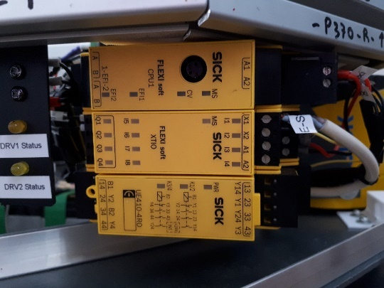Safety PLC used is FLEXI soft with the three modules

* CPU1: CPU unit with EFI port connected to Laser Scanner
* XTIO: Input-Output module
* UE410-4RO: Relay module, not used so far

Programming of the device is done using the orange cable from sick connected to the front of the CPU1 and using the PC software FLEXI soft Designer.

The input/output used from the XTIO module are:

|  |  |  |  |
| --- | --- | --- | --- |
| Pin | Reference | Function | Connection |
| I1 | Safety switch | Emergency Stop button | From Emergency Stop button (0v by default, 24v if activated) |
| I2 | EX-Stop | External stop | From LLC. 0v=Stop active (default) |
| I3 | LCase1/2 | Case selection A | From LLC. 0v=0, 24v=1 |
| I4 | LCase2/2 | Case selection B | From LLC. 0v=0, 24v=1 |
| I8 | Remote Stop | Remote emergency stop | From remote emergency stop device |
| Q1 | ON DRV1 | Activate Drive 1 | To Drive 1 ON/OFF input |
| Q2 | ON DRV2 | Activate Drive 2 | To Drive 2 ON/OFF input |
| Q3 | SAFETY STOP ON | Indicate status | To LLC. 24v=Safety stop activated |

## PinHook System

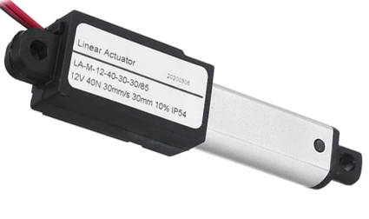PinHook system use a linear actuator

Characteristics:

* Supply voltage Vs: 12 V DC
* Power consumption :
* Speed 30mm/s
* Force: 40N

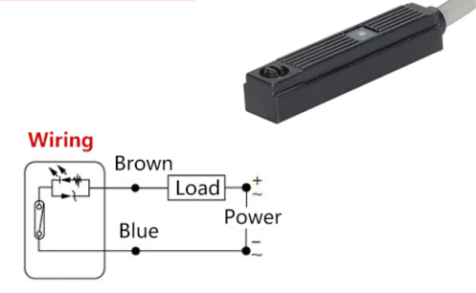The system counts with a magnetic sensor of *reed* type and includes a LED to determine activity. The Pin of the PinHook has a permanent magnet inside in its base, so the sensor will detect the magnet when the Pin is contracted (low position)

As of today, the sensing part do not work well because the magnet installed is not strong enough to activate always the sensor, so its output has not been connected to the LLC, but here it is described a proposal of the conditioning circuit that would be needed in the LLC:

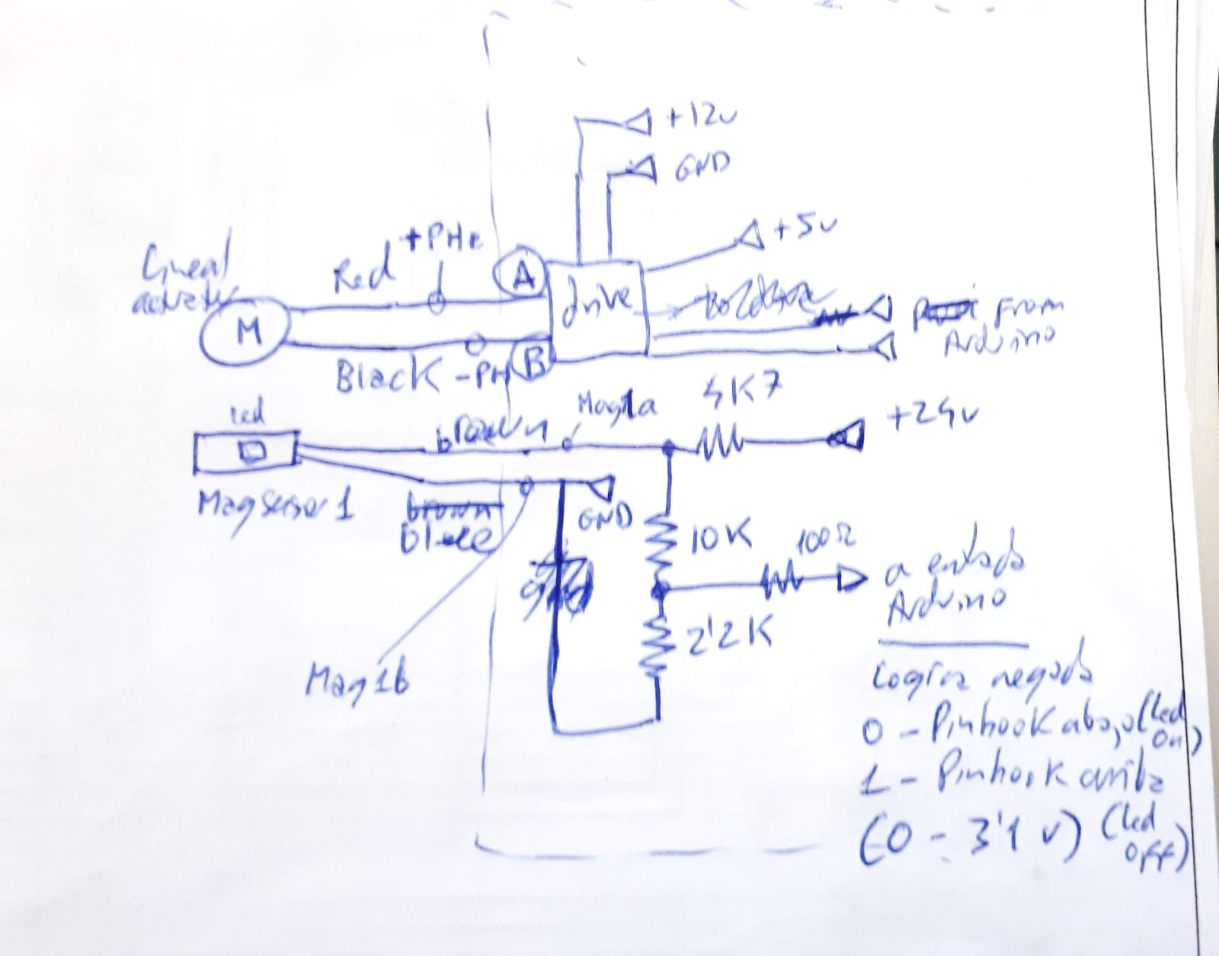

## Sensors

### Push Button (Rearm)

There is a push button at the back of the AMR, with integrated white LED

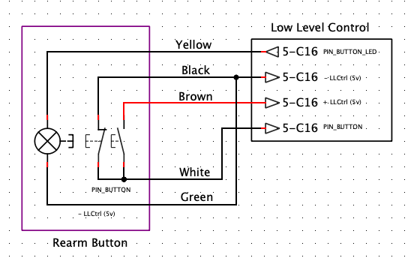

### Magnetic Band Sensor

The magnetic band sensor used is Macome GS4484. There is not much information about this product. After characterizing it, looks like it could work properly with magnetic bands up to 2cm wide.

Characteristics:

* Internal sensors: 15 magnetic sensors
* Power: 25v/30mA
* Height of detection: Up to 45mm
* Lateral detection: up to 90mm at each side

Signals:

* **Gate OUT** (Brown cable): Digital output. Negative Logic. Detection of band. If detected: 0v if not detected: 24v
* **Deviation OUT** (White cable): Analog output. Range from 2v to 8v depending on the position of the magnetic band.
* **Sel1 IN** (Blue cable), **Sel2 IN** (Yellow cable): Digital input. 24v logic. Selection of working mode.

|  |  |  |
| --- | --- | --- |
| **Straight mode**  Sel1 IN: 0v  Sel2 IN: 0v | **Left Mode**  Sel1 IN: 24v  Sel2 IN: 0v | **Right Mode**  Sel1 IN: 0v  Sel2 IN: 24v |
|  |  |  |

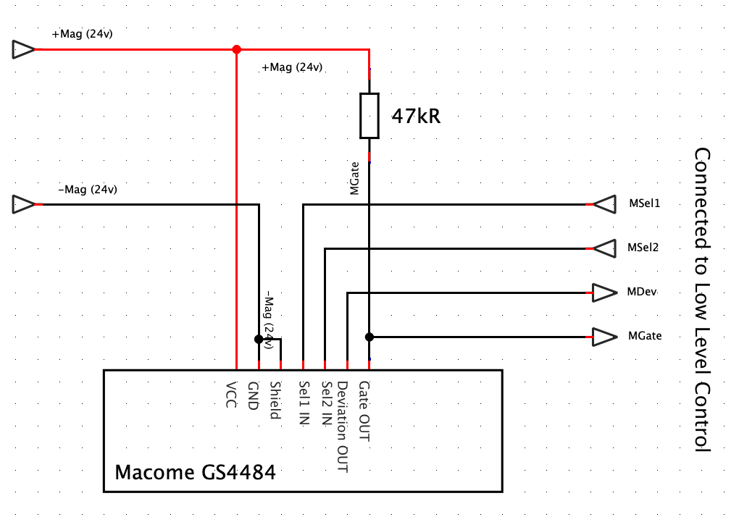

In order to adapt the logic levels, we will use a 5v🡪24v converted for Sel1 IN and Sel2 IN, voltage divider for Gate OUT (10K/2K2) and also a voltage divider for Deviation OUT (3K3/5K6)

### RFID interrogator

The RFID reader (interrogator) used is SICK RFH630 standard. The interrogator RFH630 is an ISO/IEC-15693 compatible transponder writing/reading device with integrated antenna for the close-up range. All the components are located in a housing suitable for the industry. The interrogator RFH630 is an intelligent sensor for automatic and non-contact detection of RFID transponders.

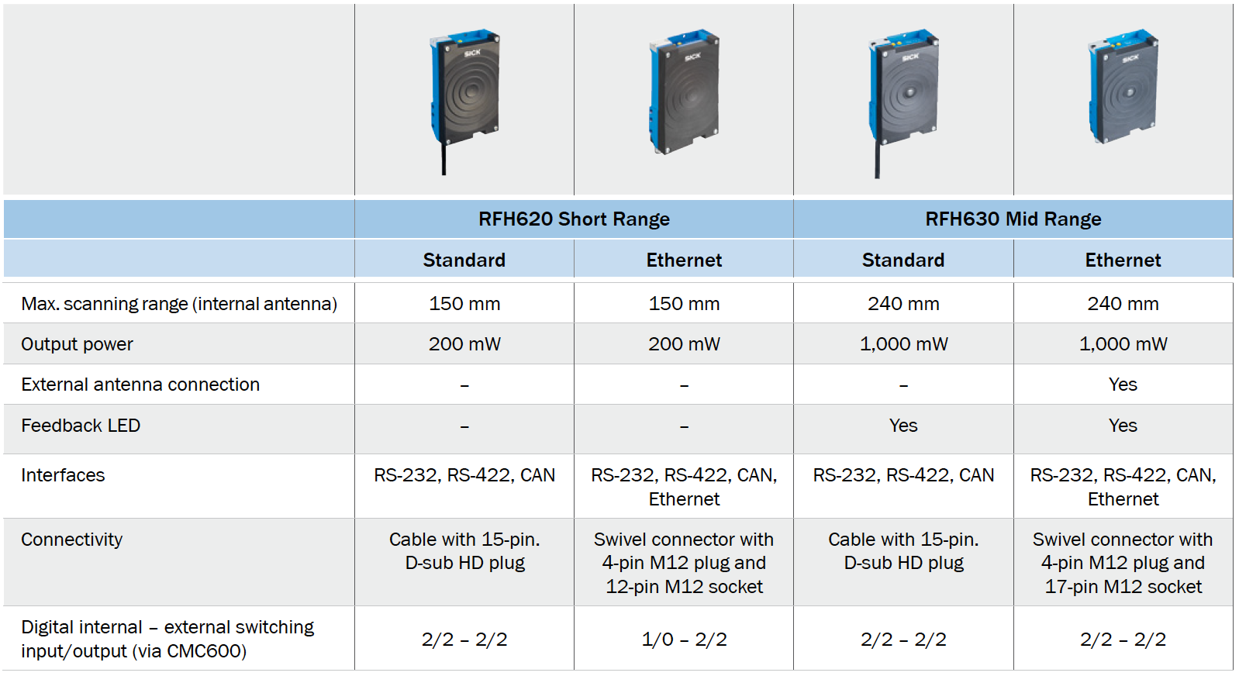

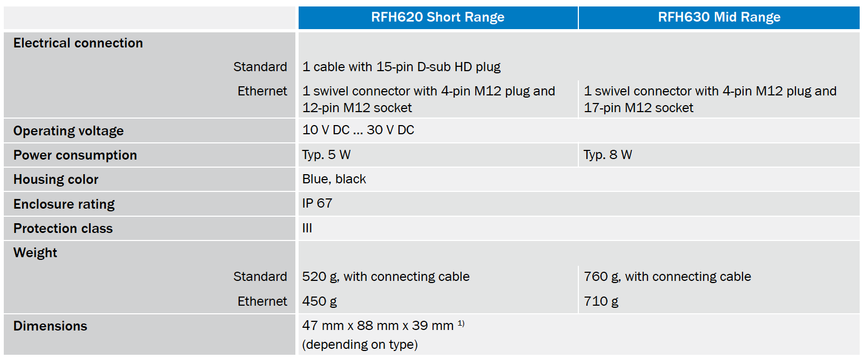

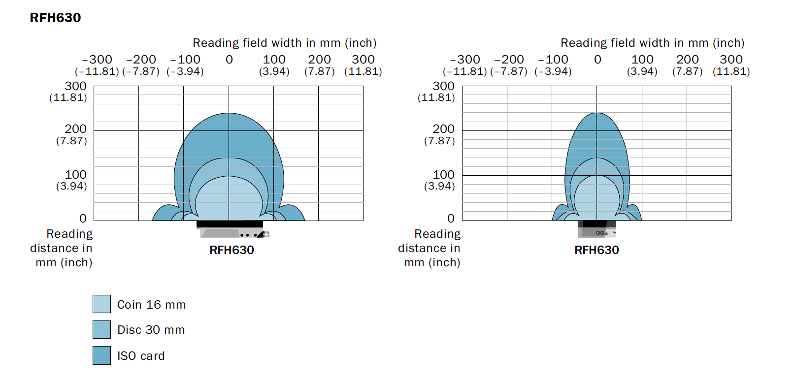

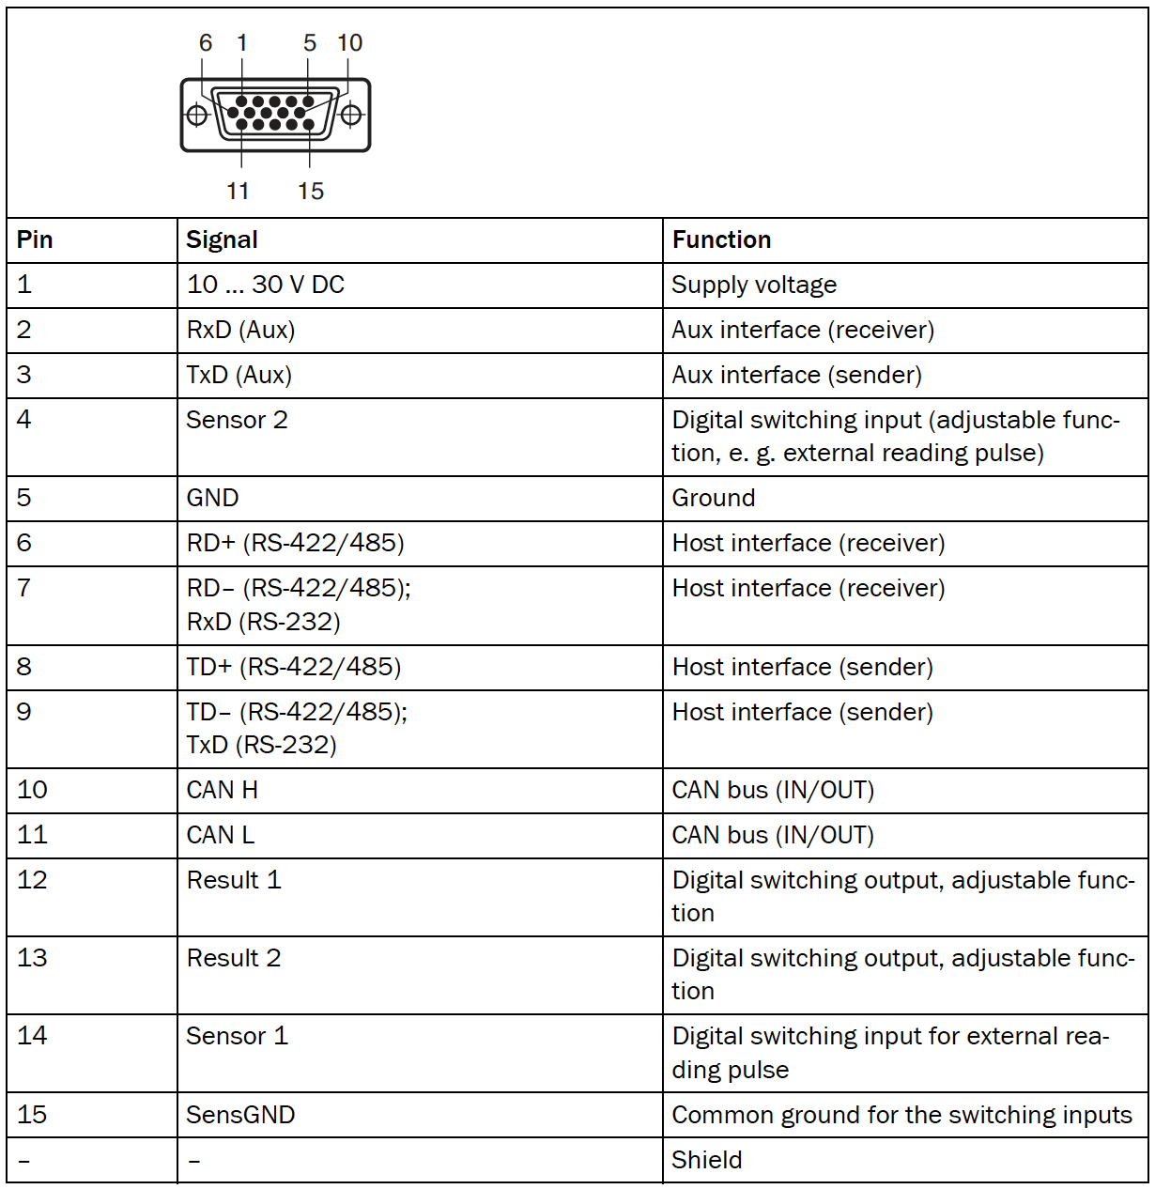

For our application we will only use the Aux interface sender (TxD), that send the information read at 57.600Bd in inverted format, with 1 bit start, 1 bit stop, no parity.

## Control system

Control system is composed of two controllers:

* LLC (Low-Level Controller), responsible of all low-level functions like motors control, sensors read, magnetic band guidance, …
* HLC (High-Level Controller), responsible for the high-level functions, like slam based navigation, HMI,…

Let’s see both and all their parts.

### Low Level Controller (LLC)

LLC is the device that controls the Low-Level functionalities of the AMR. For more details on those functionalities, go to the SW design section.

LLC is powered by 24v and 5v coming from the main DCDC regulators.

LLC is connected to the following devices via specific connectors:

1. **Lidar** (4 wires, one for the reset of the lidar and three to detect status of the lidar)
2. **HLC** (3 wires for the TTL-Serial interface between HLC and LLC)
3. **Drives and Pinhook** (4 wires. Two to power the Pinhook and two for the PWM signals of motor drives, so it goes to the PWM to Analog converter described in following section)
4. **Rearm back button** (4 wires, to detect the status of the button and to manage the led ring)
5. **Power** (4 wires. Two for the 5v and two for the 24v. It is assumed that the grounds are connected at the sources, not inside LLC box)
6. **Magnetic Sensor** (4 wires to configure and read the Magnetic band sensor)
7. **Encoder 1** (4 wires to power (5v) and read the encoder pulses of Motor1)
8. **Encoder 2** (4 wires to power (5v) and read the encoder pulses of Motor2)
9. **Flexi** (4 wires. one to receive a high level if the Flexi is in safety mode, one to ask the Flexi to make a forced stop and two to ask the flexi to configure the Lidar cases)
10. **RFID interrogator** (3 wires to power and read the RFID interrogator)

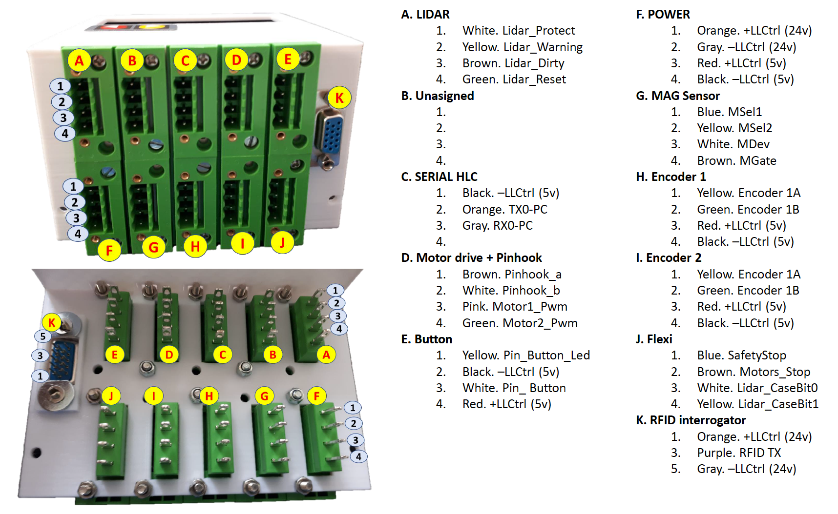

Inside LLC box we could find the following boards:

* Arduino Mega 2560
* Signal 5v to 24v converter board
* LCD screen board
* Custom circuit board

Following they are described the different boards:

#### Arduino Mega 2560

It is a normal Arduino Mega board over which it has been installed a tailored made hat (Custom circuit board). It is not an industrial device, but serves the purpose of fast prototype development and testing.

#### Signal 5v to 24v converter board

Arduino works with TTL 5v levels. Therefore, a level converter from 5v to 24 levels is needed in order to connect to industrial devices.

5v to 24v level conversion is done via a breakout board. Specifically, Al-Zard DST-1R8P-N board is used. This module comes with different conversion levels. The one we will use is the 5v->24v model.

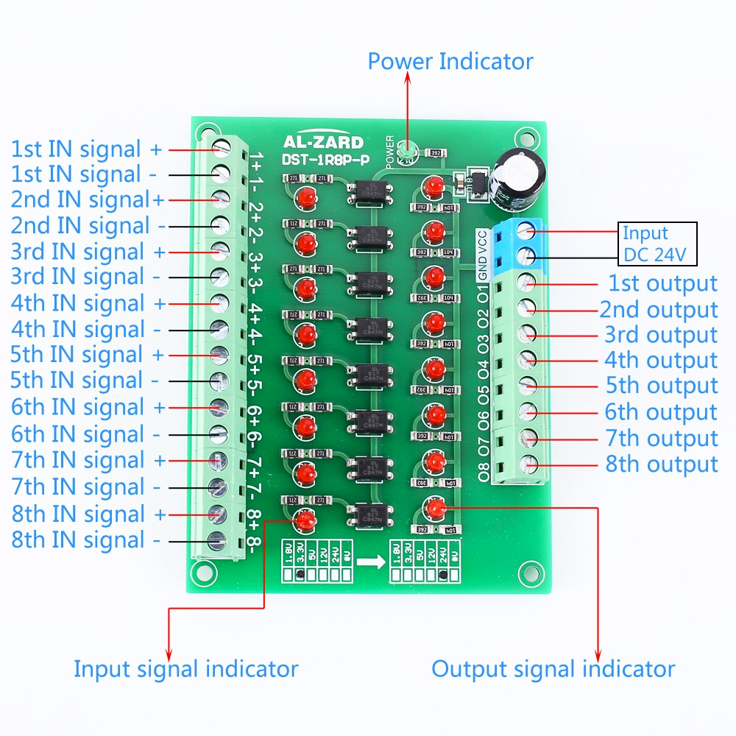 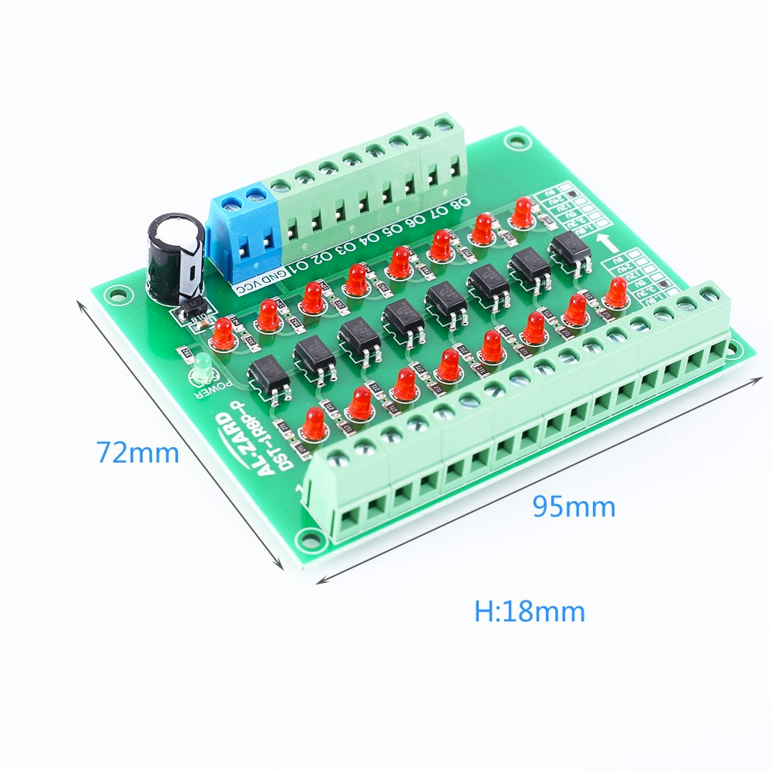

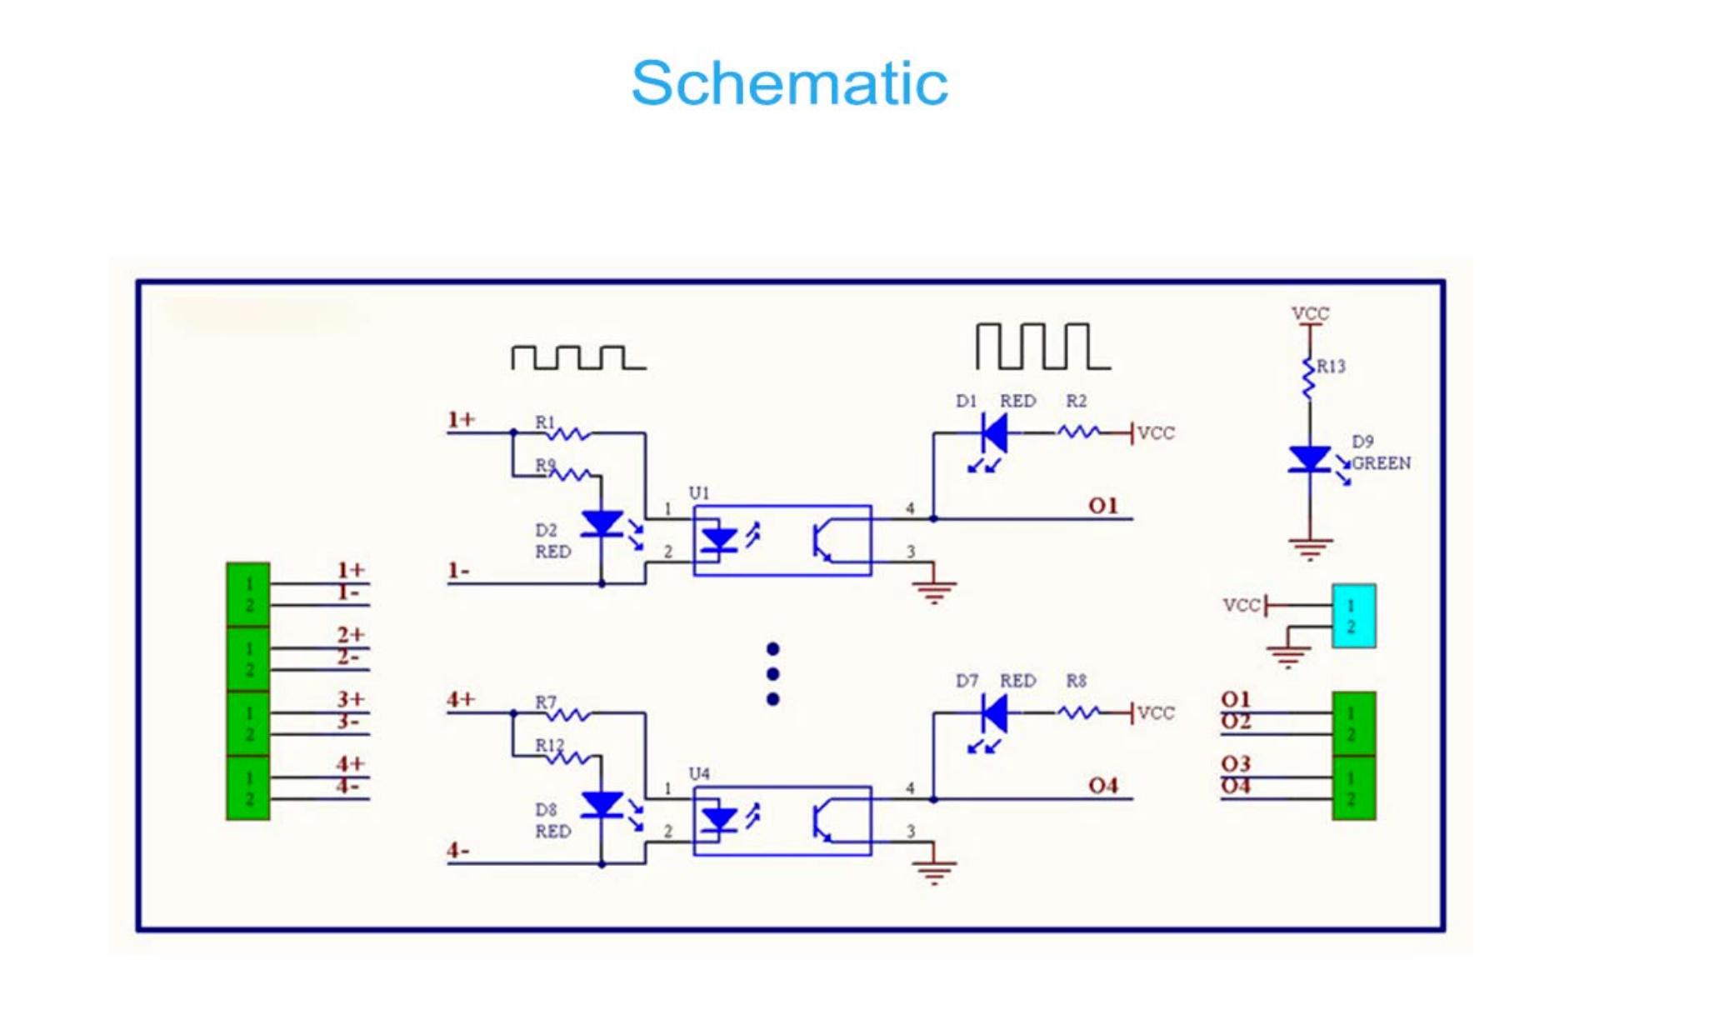

DST-1R8P-P is a 8CH optocoupler isolator for signal converter. It is used for digital signal one-way conversion and PNP output.

Characteristics:

* Optocoupler isolator
* Model: DST-1R8P-P
* Work voltage: DC 24V
* Input signal voltage: DC 5V
* Output signal voltage: DC 24V
* Output current: about 15mA
* Conversion channel: 8channels
* Conversion frequency: 20KHz
* Output type: PNP
* Operating Temperature: -20℃~85℃
* Operating Humidity: 5%~95%RH
* Module Size:95*72*18mm

The module has inverted logic. It means that if we provide in a channel ground to the negative pin and 5v to the positive pin (HIGH level), we get the leds of that channel on and 0v (LOW level) at the output channel. And if we provide 0v (LOW) to the input, we get the leds off and 24v (HIGH level) at the output.

In order to keep the logic levels equal in both sides, we need to use a *Common anode signal Input* configuration. This means that input and output levels will be equal (LOW-> LOW, HIGH-> HIGH) but leds will be on when LOW level and of when HIGH level

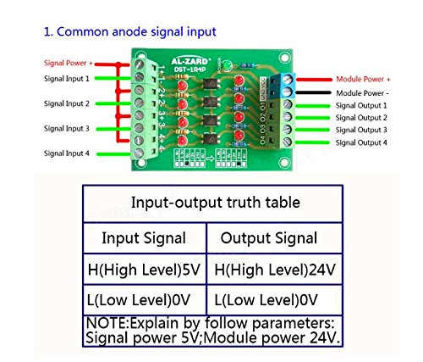

#### LCD screen board

LLC uses a 20x4 text LCD screen. It may be controlled via serial or I2C, but in this application it has been used I2C. Also, it allows for a Keypad, but this functionality has not been used.

A single jumper link is used to select Serial or I2C mode. When the jumper is present the module is in serial mode. When the jumper is removed the module is in I2C mode. This is our case.

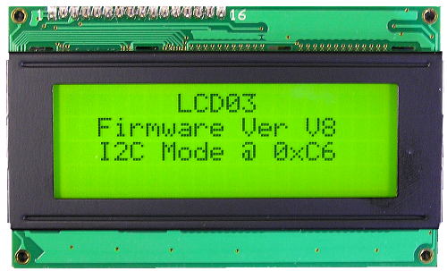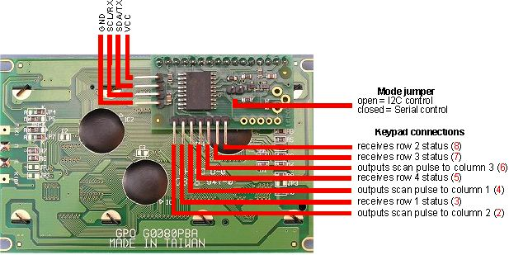

#### Custom circuit board

A custom circuit board has been installed over the Arduino board. This Custom Circuit Board includes:

**A. Pololu MD01A driver for the pinhook**

This driver is no longer available in the market. It is similar to the following one, although it has 8 pins, while the one we used has 7 pins (Pin CS is not included)

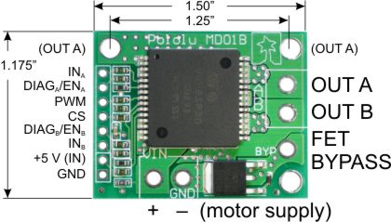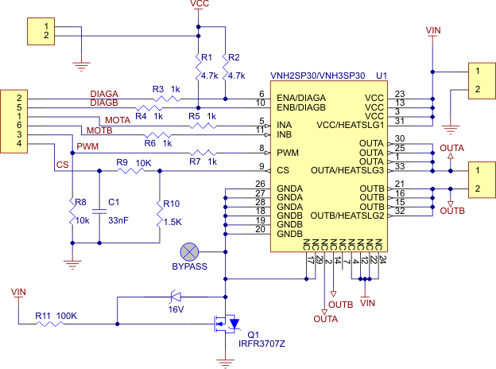

Link to the product: <https://www.pololu.com/product/705>

Also, it has been included a linear DCDC regulator (LM7812) to provide 12v for the motor supply of this driver.

**B. Conditioning circuit for RFID interrogator signals**

For our application we will only use the Aux interface sender (TxD) of the RFID interrogator, that sends the information read at 57.600Bd in inverted format, with 1 bit start, 1 bit stop, no parity.

Output voltage range is 7.4v for high level and -8.2v for low level, so compatible to RS232 levels. The conversion to readable TTL levels has been done using basically a 1N4148 fast switching diode to eliminate the negative component and a 1N4733A 5.1v Zener diode to limit the positive component. After it a 7414 Schmitt trigger inverter is used to invert and condition properly the signal, getting a clean TTL signal readable by a serial port of the *Low-Level Control System*. No optocoupler is used because is not adequate for the speed of the signal.

Following is the conditioning circuit used for the RFID interrogator

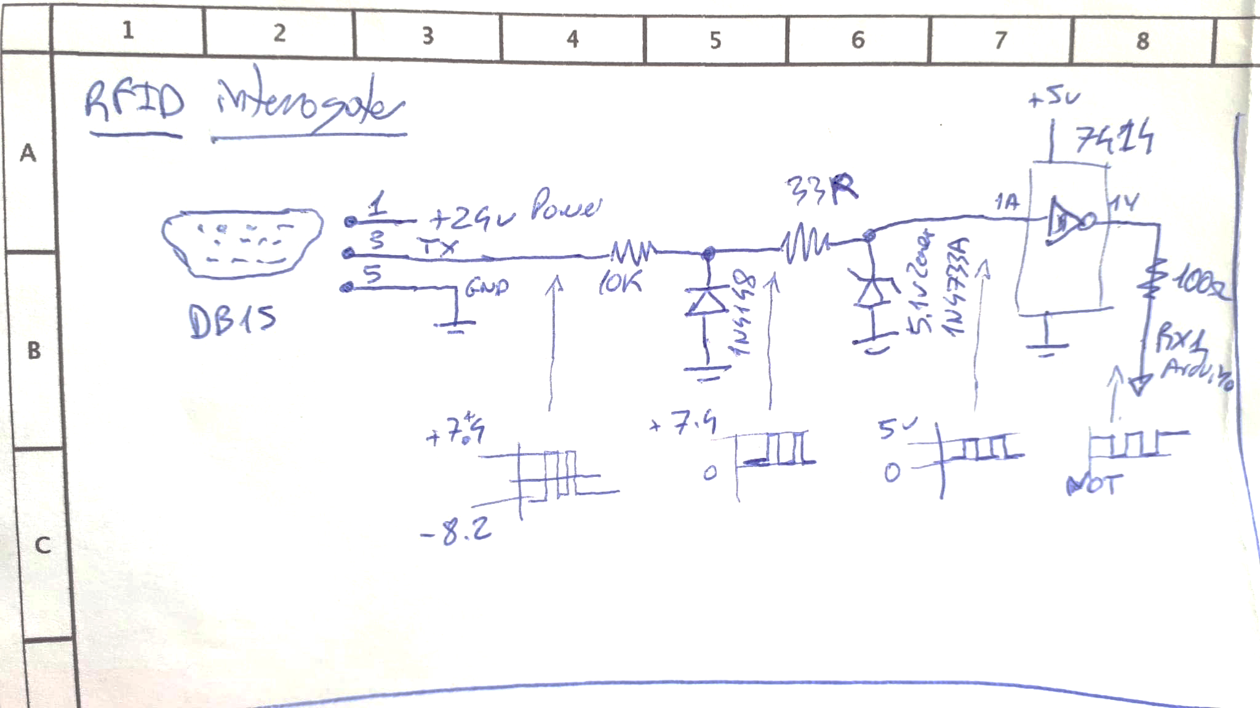 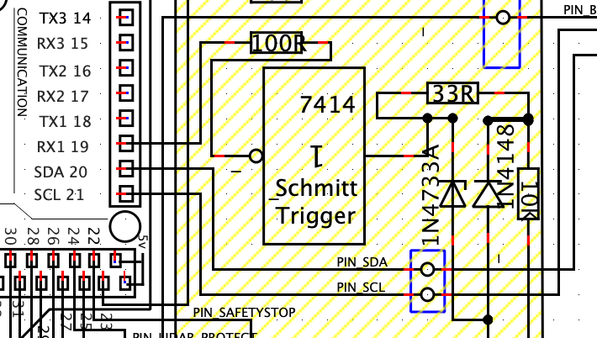

The signal resulting is five bytes burst sent every time the interrogator detects an RFID tag. The first four are fixed and correspond to the tag information. The fifth one is variable. At this moment is not known what information is sent here although probably is the number of times the tag is read.

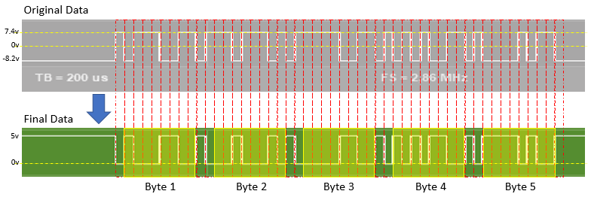

**C. Resistors based voltage dividers** (10K/2K2) to convert all those 24v input signals to 5v

**D. Some 100R resistors** in line with input signals to prevent shortcuts if by mistake they are configured as outputs.

**E. A buzzer** for notifications to users

**F. A two keys membrane keypad** for the control of the menus on LCD

Following is the scheme of the complete LLC set:

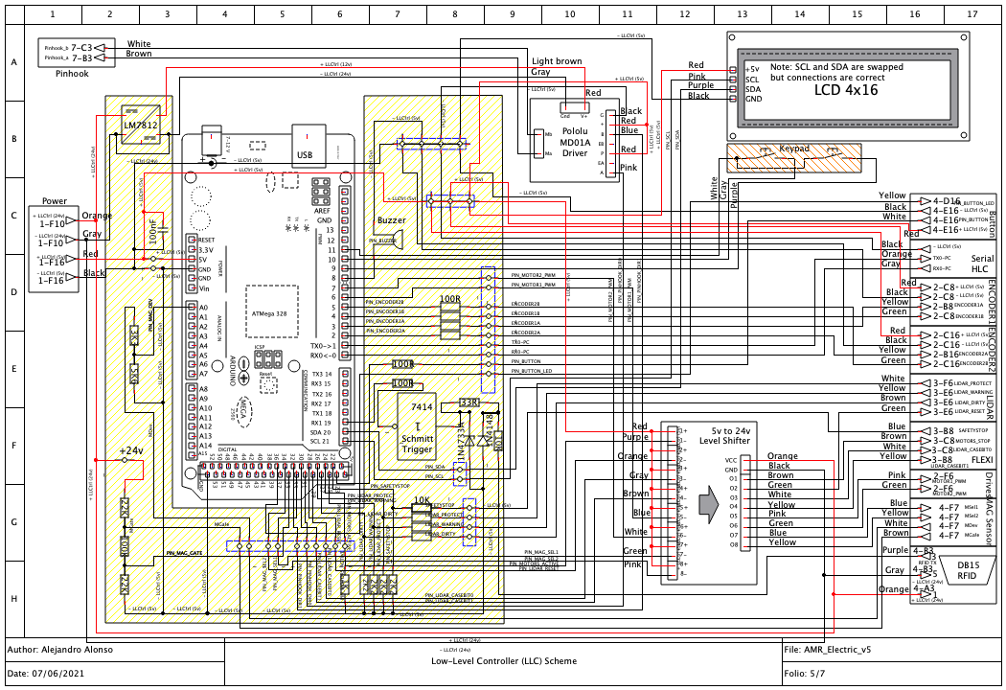

### High-Level Controller (HLC)

General electrical view of the HLC:

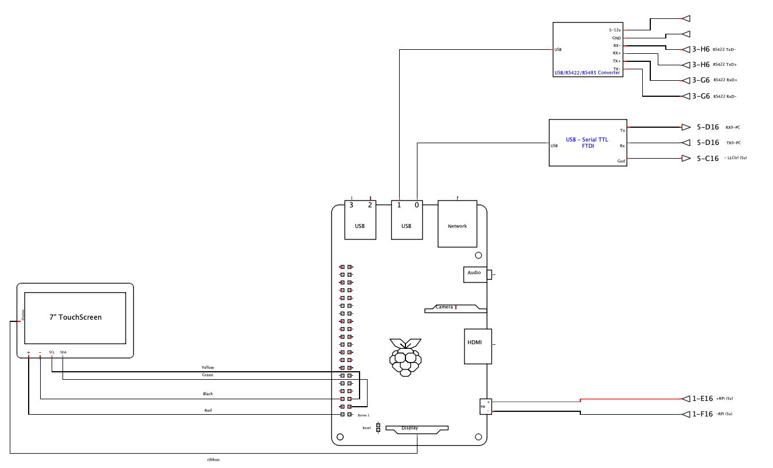

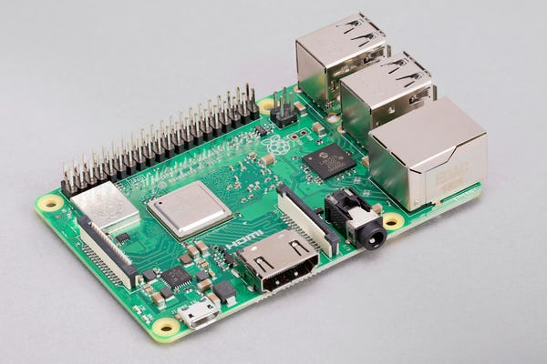

#### Single Board Computer

HLC is the embedded system (Single board computer or SBC) where the High-level programs works. It is a Raspberry Pi 3B+

Technical specifications:

* Broadcom BCM2837B0, Cortex-A53 (ARMv8) 64-bit SoC @ 1.4GHz
* 1GB LPDDR2 SDRAM
* 2.4GHz and 5GHz IEEE 802.11.b/g/n/ac wireless LAN, Bluetooth 4.2, BLE
* 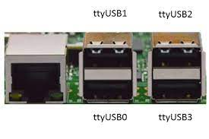Gigabit Ethernet over USB 2.0 (maximum throughput 300 Mbps)
* Extended 40-pin GPIO header
* Full-size HDMI
* 4 USB 2.0 ports
* CSI camera port for connecting a Raspberry Pi camera
* DSI display port for connecting a Raspberry Pi touchscreen display
* 4-pole stereo output and composite video port
* Micro SD port for loading your operating system and storing data
* 5V/2.5A DC power input

#### Touchscreen

Rpi is connected to a 7” Touchscreen.

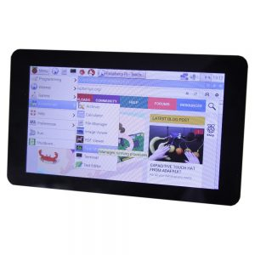

RPi and screen are connected via a DSI ribbon cable and four jumper wires with the power and I2C bus

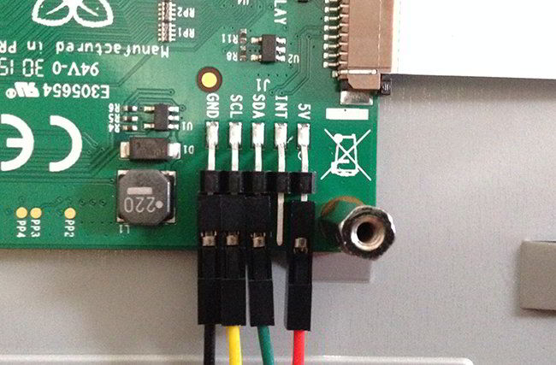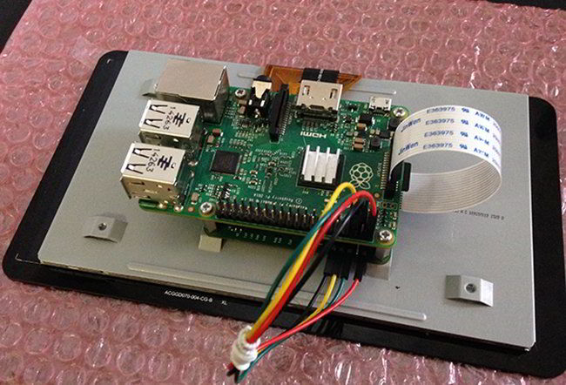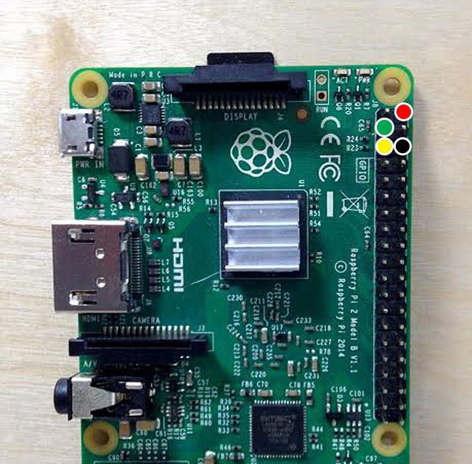

Technical specifications:

* 7” Touchscreen Display.
* Screen Dimensions: 194mm x 110mm x 20mm (including standoffs)
* Viewable screen size: 155mm x 86mm
* Screen Resolution 800 x 480 pixels
* 10 finger capacitive touch.

#### High Quality FT232RL FTDI USB 3.3V 5.5V to TTL Serial Adapter Module for Arduino FT232 Pro Mini USB TO TTL 232HLC-LLC Serial interface

Both HLC and LLC are connected via a serial port. For that, it is used an FTDI USB-Serial TTL converter.

#### HLC-Laser scanner RS422

Laser scanner has a RS422 port to send data. This data is collected by HLC for navigation based on SLAM.

Data is converted to USB port (HLC) via a universal USB/RS-485/422 converter

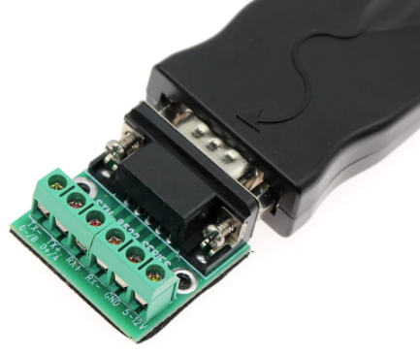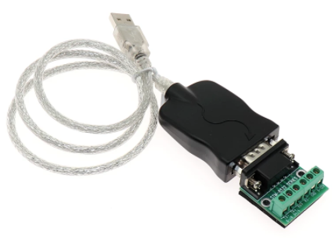

Technical specifications:

* Fully compatible with USB (Universal Serial Bus) Rev 2
* Support RS-485/422 interface
* RS-422/485 interface DB9 pin connector
* Data (TXD) automatic flow control, zero delay design
* Data transmission rate above 1Mbps
* Support automatic handshake protocol
* Support remote wake-up and power management
* The USB bus takes power directly without external power supply
* +/-15KV ESD Antistatic protection
* Use environment: -25 C to 70 C, relative humidity 5% to 95%
* Support Win98/Win2000/WinXP/Vista/Win7/Linux and so on

# Software Design

## Cloud System

Cloud system allows monitoring of the AMRs from web browsers. It is based on Amazon Web Services (AWS). The global architecture of the monitoring is as follows:

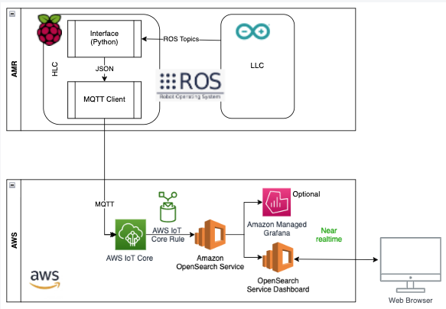

The top part (AMR) is explained in both the HLC and LLC sections, so in this section we will focus on the lower part (AWS)

In summary:

* The AMR send MQTT messages to the cloud via the AWS IoT Core Service, that act as MQTT server and broker. For that the AMR use some libraries provided by AWS
* AWS IoT service use an IoT rule to send the messages received to Amazon OpenSearch Service.
* Amazon OpenSearch Service (open-source derived from Elasticsearch 7.10.2. It is a full-text search engine. In our case, we’ll use it as a database to store telemetric data.
* OpenSearch Service Dashboard (open-source derived from Kibana 7.10.2) is the data analytics tool.

An account in AWS should be created.

### AWS IoT Core

AWS IoT provides the cloud services that connect IoT devices to other devices and AWS cloud services. AWS IoT provides device software that can help integrate IoT devices into AWS IoT-based solutions. If devices can connect to AWS IoT, AWS IoT can connect them to the cloud services that AWS provides.

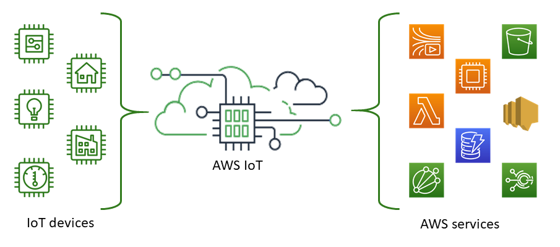

In our case is the LLC send some information to HLC via ROS topics (explained at LLC ROS Integration and Subscriber to data for monitoring) and HLC resends that information to AWS IoT. How to create the IoT Core service and get HLT connected to it is explained under de section HLC Cloud monitoring connection

Monitoring data is received as JSON:

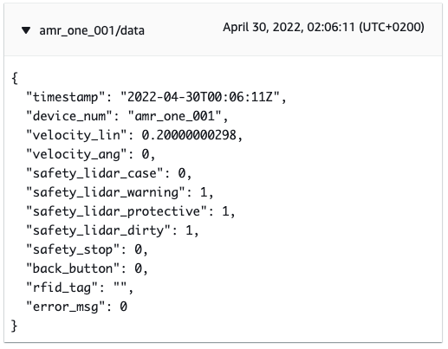

### OpenSearch Services

As mentioned, It is a full-text search engine. In our case, we’ll use it as a database to store telemetric data.

Steps followed for the creation of a domain to store data:

1. Go to AWS dashboard and look for Amazon OpenSearch Service
2. Click on "Create domain”. Then you go to a configuration page:
   1. Enter a Domain name that is representative. In my case “amr-monitoring"
   2. On Deployment type I set "Development & Testing” and v1.2 of Opensearch
   3. Autotune disabled
   4. Data nodes. Instance type: t3.small.search
   5. Network: Public access
   6. ~~Fine-grained access control: I set default and introduce IAM ARN: arn:aws:iam::840237993118:user/aalonso (it is under IAM service, Users)~~
   7. Fine-grained access control: I set "Create Master User” and choose a user: aalonso and the same pwd as the AWS console user.
   8. Access policy: Only use fine-grained access control
   9. Click on Create. It will take 15m or so to create.

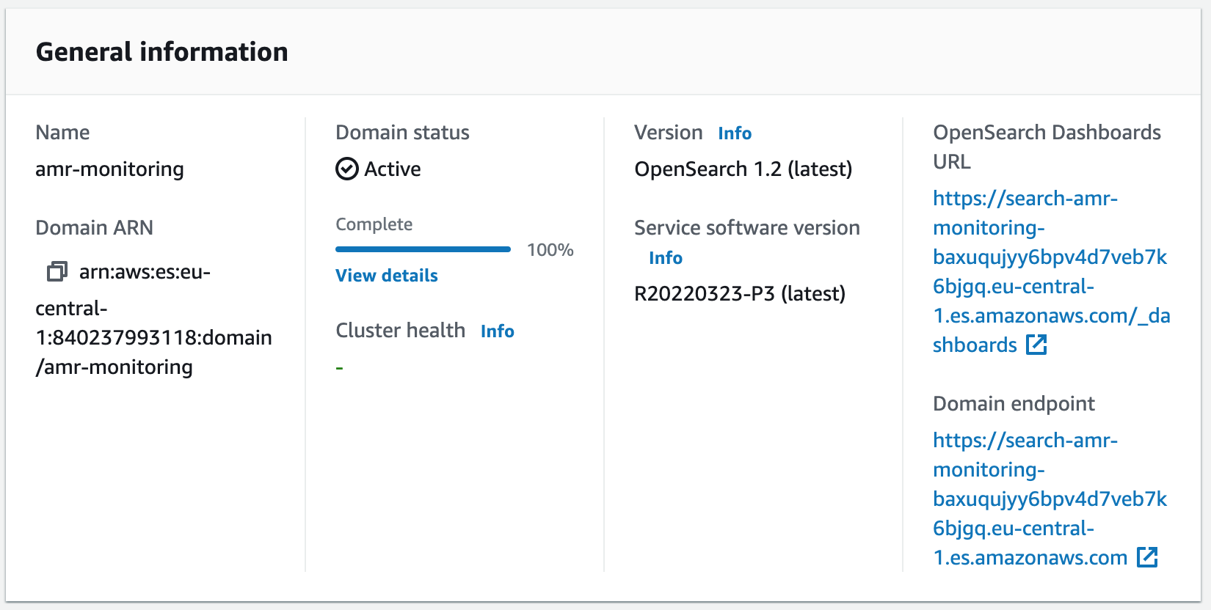

Domain endpoint:

[https://search-amr-monitoring-baxuqujyy6bpv4d7veb7k6bjgq.eu-central-1.es.amazonaws.com](https://search-amr-monitoring-baxuqujyy6bpv4d7veb7k6bjgq.eu-central-1.es.amazonaws.com/)

### IoT Rule

Now, we’ll need to setup a rule so that all incoming messages into AWS IoT will be published to the OpenSearch.

To configure a rule:

1. Go to AWS IoT Service, Act, Rules.
2. Click on "Create a rule". A configuration page appears:
   1. Give a name. In my case “amr_to_opensearch"
   2. Rule query statement: SELECT * FROM ‘amr_one_001/data‘
   3. Add action: Send messages to the Amazon OpenSearch Service. Click Configure Action
   4. Chose a resource: amr-monitoring (created in previous step)
   5. Endpoint: No action required, automatically selected
   6. ID: ${newuuid()}
   7. Index: amr
   8. Type: _doc
   9. Role name: Click “create a new role” so that AWS automatically creates it. In my case name “amr_role”. Then ADD ACTION button
   10. Click on "Create role” button
3. Enable the rule (click on … and select enable)

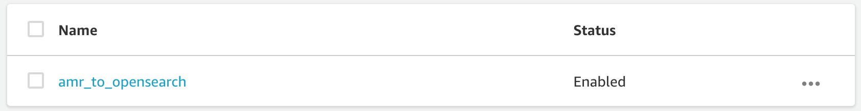

Start sending data:

1. Switch on LLC and HLC
2. Connect via ssh to RPi “ssh turtlebot@turtlebot.local”
3. In one terminal: roscore
4. In another terminal: rosrun rosserial_python serial_node.py /dev/ttyUSB0
5. In another terminal:  
   roscd amr_one_hlc

roslaunch amr_one_hlc ros_to_awsiot.launch

### OpenSearch Dashboards

OpenSearch Dashboards is the default visualization tool for data in OpenSearch.

OpenSearch Dashboards URL:

<https://search-amr-monitoring-baxuqujyy6bpv4d7veb7k6bjgq.eu-central-1.es.amazonaws.com/_dashboards>

When accessing it is asked for a User and Password. I configured it to be the same as the AWS console IAM user. Then follow the next steps for the first time:

1. Select “Explore on my own”
2. We need to create the index (name of the table) so I go to "DevTools”at the left and write the following at the left. Then I click on the run icon (triangle)

PUT amr

1. Then, I activate the ingestion system: MQTT publishing and IoT rule, so it starts feeding the DB. I could check if data is coming by running:

GET amr/_doc/_search

1. Go to Stack Management, select Index patterns, then select "Create Index pattern”
2. Enter the index pattern name. In my case amr*
3. Then select the timestamp field for time field and click on Create
4. Now I could create the elements for the dashboard via "visualize” menu and after having some visualizations, I could add them to a dashboard

This is the final dashboard:

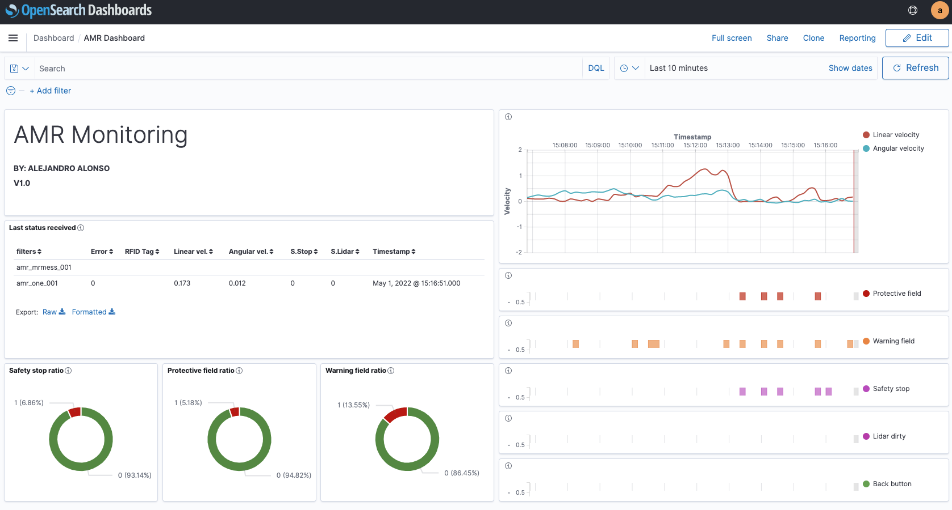

There is an emulator, so you could generate data from HLC. To get it running, execute in HLC:

roslaunch amr_one_hlc sim_to_awsiot.launch

## Safety System

### Safety Laser

The Laser scanner used is, as mentioned before, the Sick s300 Expert. In order to do the parametrization of this device we need to use the orange programming cable from Sick. As this Laser Scanner is connected to the FLEXI soft safety PLC, the parametrization of the laser scanner could be done either connecting the cable to the FLEXI soft and using the FLEXI soft Designer software, or connecting the cable to the front of the Laser Scanner and using the CDS software from Sick.

Here we describe some parametrizations configured for this application:

1. The laser scanner is installed upside down, so it has been configured a rotation of 180 degree for the 7 segments display
2. The application variant has been configured as Mobile
3. Activated A and B inputs only, for cases selection (up to 4 cases) from the FLEXI soft via EFI
4. 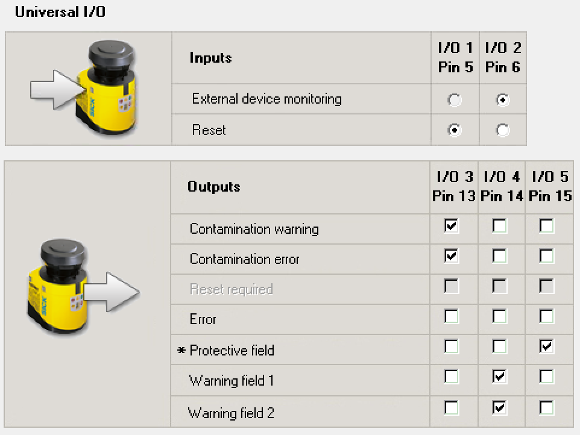Universal I/O (Pins 5, 6, 13, 14 and 15) have been configured as follows:
5. Two field sets (long and short) have been configured with one warning field and one protective field each. Another field set with no fields have been configured to use in a special case where no safety based on laser is active.

|  |
| --- |
| Safety Laser Scanner distance calculations[1]  In the following calculations only consider the velocity of the vehicle, not the speed of the person walking. This assumes that the person will recognize the danger and stand still.  For vehicle protection, observe EN 1525 “Safety of industrial trucks. Driverless trucks and their systems”[2].  The protection zone must be configured to ensure the minimum safety distance, which has been calculated according to the laws, regulations, and standards of the country and region in which the system will operate.  Imagen que contiene mapa, texto  Descripción generada automáticamenteExample of installing to an AGV (automated guided vehicle)[3]:  Figure . AGV case. Source: Keyence  S = V x T + Sbrake x L + Z   * S: Minimum safety distance in millimeters * V: Maximum approach speed of the AGV in millimeters per second * T: Overall response time in second (t1 + t2)   + t1: SZ response time in second   + t2: Max. time in second that AGV responds after receiving the OSSD signal from SZ. * Sbrake: Required distance for braking AGV in millimeters * L: Safety coefficient for required distance based on the wear of braking * Z: Additional distance in millimeters, ZSZ+ZG (mm)   + ZSZ: Supplementary necessary distance for SZ in millimeters   + ZG: Supplementary necessary distance in millimeters, if "h" is not enough.   + h: Space between the reference plane (floor) and the bottom of AGV.   If the "h" is not enough ensured, you must consider the risk that the toe or toe tip is caught between the ground (floor) and the AGV. The relationship between "h" and "ZG" is as follows.   * P1, P2, P3: Protection distances to be configured as the protection zones * W1, W2: Width of the AGV * B: Distance between the front edge of the SZ and protection zone origin on the SZ * D: Unprotected space * H: Height of detection plane (protection zone) above the reference plane in millimetres, for example the floor. "H" must be less than 200 mm. |

Based on this, the safety distance calculations for AMR-ONE are (many values are taken from examples):

· V = 1000 mm/s (Limited by sw of LLC)

· T = t1+t2 = 0.19 s Overall response time

· Sbrake = 30mm Required distance for braking AGV in millimetres

· L = 1.1 Safety coefficient for required distance based on the wear of braking

· Z = ZSZ+ZG = 50+100 = 150mm Additional distance in millimetres (mm),

o ZSZ = 50mm Supplementary necessary distance for SZ in millimetres

o ZG = 100mm Supplementary necessary distance in millimetres, if "h" is not enough.

o h = 60mm Space between the reference plane (floor) and the bottom of AGV.

· B = 45mm Distance between the front edge of the SZ and protection zone origin on the SZ

· W1 = W2 = 200 mm Width of AGV

Safety Distances:

S = V x T + Sbrake x L + Z = 1000 x 0.19 + 30 x 1.1 + 150 = 373mm, so 37cm,

but this is in case the AMR goes at 1m/s (Long field), what really in practice rarelly will happen. In the normal situation at home, the speed will never be higher than 0.2m/s, so V = 200mm/s, being

S = V x T + Sbrake x L + Z = 200 x 0.19 + 10 x 1.1 + 150 = 199mm, so 20cm,

Therefore, long field S=37cm and short field S=20cm with width of 50cm

although if the AGV goes at 0.3m/s or less, the system is considered safe, so really the short one could be even less.

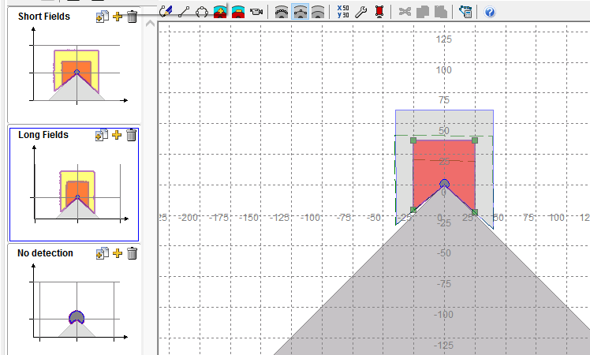

1. 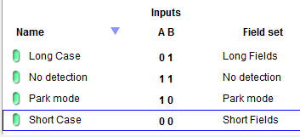Four Cases have been configured based on inputs A and B from FLEXI soft as follows:

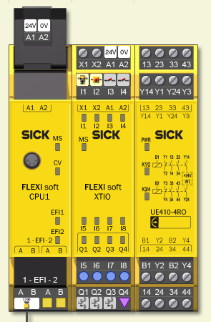

### Safety PLC

Safety PLC used is FLEXI soft with the three modules

* CPU1: CPU unit with EFI port connected to Laser Scanner
* XTIO: Input-Output module
* UE410-4RO: Relay module, not used so far

Programming of the device is done using the orange cable from sick connected to the front of the CPU1 and using the PC software FLEXI soft Designer (Default password: SICKSAFE).

As mentioned in the hardware section, the input/output used from the XTIO module are:

|  |  |  |  |
| --- | --- | --- | --- |
| Pin | Reference | Function | Connection |
| I1 | Safety switch | Emergency Stop button | From Emergency Stop button (0v by default, 24v if activated) |
| I2 | EX-Stop | External stop | From PLC. 0v=Stop active (default) |
| I3 | LCase1/2 | Case selection A | From PLC. 0v=0, 24v=1 |
| I4 | LCase2/2 | Case selection B | From PLC. 0v=0, 24v=1 |
| Q1 | ON DRV1 | Activate Drive 1 | To Drive 1 ON/OFF input |
| Q2 | ON DRV2 | Activate Drive 2 | To Drive 2 ON/OFF input |
| Q3 | SAFETY STOP ON | Indicate status | To PLC. 24v=Safety stop activated |

The logic is defined in two pages. One for the inputs and one for the outputs (and decision taking)

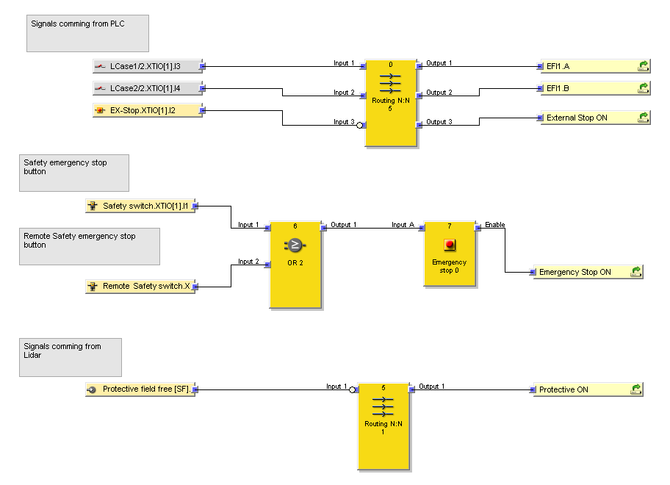

Figure 1. Inputs

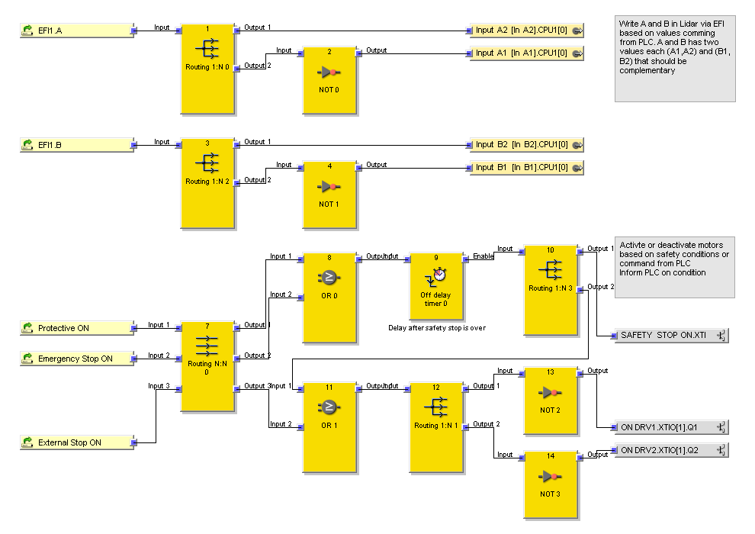

Figure 2. Outputs

The logic is very simple:

* Based on the values of LCase1/2 and LCase1/2 the values of A and B in the laser scanner are updated via EFI port. These values allow setting the Case to use.
* In the following cases we activate de safety condition stopping both motors via ON DRVx outputs and activating the SAFETY STOP ON output to inform the PLC of the situation:
  1. If the Protective field of the laser scanner is compromised
  2. If the Emergency Stop Button is pushed

In case the safety condition is active due to Protective field compromise (case a), then in the moment this field is no longer compromised, the safety condition will be released, but after 2 seconds as there is a timer on that situation, to prevent many continuous stops if an obstacle is moving in the protective field.

* Also, If the signal present at EX-Stop is 0v (default), Safety PLC will stop motors, but neither enter in Safety Mode not activate the SAFETY STOP ON output. This signal could be changed by the Low-Level Control. As this signal is 0v by default, the system starts with the motors blocked by default and will not be released from this condition until this signal is put to 24v. This signal is useful for two reasons:

1. To ensure the motors do not move before there is a PWM available for the drives (via converter). Otherwise, motors would stop moving at fast speed.
2. Due to other reasons where the Low-Level control wants to stop the AMR

## Low-Level Controller (LLC)

LLC is the device that controls the Low-Level functionalities of the AMR. It includes:

* Motors’ velocity control
* RFID tags detection and actions
* Magnetic band detection and guidance
* Pinhook control
* Rearm button
* Sound signals
* Lidar and Safety
* LCD and keypad
* External commands from PC
* ROS integration

As Low-Level Control System we use an Arduino Mega 2560. It is not an industrial device, but serves the purpose of fast prototype development and testing.

Following it is described the approach to use the different devices connected to the LLC and manage the behavior of the AMR based on them.

### Motors Velocity control

Motors Velocity is defined by two parameters: Linear Velocity and Angular Velocity.

#### Motor Velocity conversions

The main function to set motors velocity is

|  |
| --- |
| **void *SetMotorsVelocity (float Linear_Velocity, float Angular_Velocity)*** |

Calling this function ensure that the vehicle moves based on these values.

The purpose of this function is to convert from linear velocity in meters per second (m/s) and angular velocity in radians per second (rad/s) to specific global variables ***Motor1_setpoint*** and ***Motor2_setpoint*** that are the setpoint values used later to the PID controllers for direct control of the motors.

The range of values is as follows:

* **Linear_Velocity**: Float value in the range -*MOTORS_MaxLinear_Velocity* to *MOTORS_MaxLinear_Velocity*, being *MOTORS_MaxLinear_Velocity* a pre-processor directive defined at the beginning of the program. In the moment of writing this document *MOTORS_MaxLinear_Velocity* is 1.0m/s
* **Angular_Velocity**: Float value in the range -*MOTORS_MaxAngular_Velocity* to *MOTORS_MaxAngular_Velocity*, being *MOTORS_MaxAngular_Velocity* a pre-processor directive defined at the beginning of the program. In the moment of writing this document *MOTORS_ MaxAngular_Velocity* is 3.14

The conversion from *Linear_Velocity* to *Motors_Setpoint* Is done basically by the formula:

|  |
| --- |
| ***Motors_setpoint = Linear_Velocity * PID_Interrupt_ms * 12.875*** |

Let’s see how is this formula defined:

|  |
| --- |
| Initial constants:   * encoder CPR: 200CPR (cycles per revolution in motor axel) * gear ratio of motors: 103/4 * CPR_on_wheel (Resulting cycles per revolution in wheel axel): encoder CPR * gear ratio = 5150 cycles per revolution of wheel * Diameter of wheel: 130mm = 13cm = 0.13m * Perimeter_of_wheels_in_meters: Pi * Diameter = 0.4m * 1 minute = 60000ms   Motors_setpoint is measured in cycles of encoder per measuring time (PID_Interrupt_ms)  Speed_meters_per_minute = Linear_Velocity(m/s) * 60 seconds  revolutions_per_minute = Speed_meters_per_minute / Perimeter_of_wheels_in_meters =  (Linear_Velocity * 60) / 0.4 = Linear_Velocity * 150  revolutions_per_ms = revolutions_per_minute / 60000 =  (Linear_Velocity * 150) / 60000 =  Linear_Velocity * 0.0025  Motors_setpoint = revolutions_per_ms * PID_Interrupt_ms * CPR_on_wheel =  (Linear_Velocity * 0,0025) * PID_Interrupt_ms * 5150 =  Linear_Velocity * PID_Interrupt_ms * 12.875 |

The conversion from *Motors_Setpoint* (calculated previously) and *Angular_Velocity* to *Motor1_Setpoint* and *Motor2_Setpoint* Is done basically by the formulas:

|  |
| --- |
| **Motors_deviation = Angular_Velocity * PID_Interrupt_ms * 0.836875;**  **Motor1_setpoint = Motors_setpoint - Motors_deviation;**  **Motor2_setpoint = Motors_setpoint + Motors_deviation;** |

Basically, we convert from angular velocity to linear speed at each wheel and add or subtract to the global linear velocity for each wheel. Thus, if the global linear velocity is zero, any angular velocity different than zero would make the vehicle rotate around its centre. If the global linear velocity is different than zero and also the angular velocity is different than zero, then the vehicle would move in a curve with a specific Radius (R)

Let’s see how it is calculated.

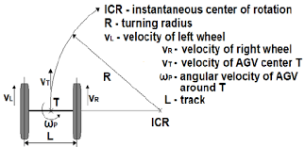By general definition:

v = ωr

being:

v = linear speed (m/s)

ω = angular speed (radians/s)

r = radius of the rotation (m)

Then:

Distance between wheels (L): 325mm = 32.5cm = 0.325m

Radius_of_rotation (L/2) = 0.065m, because the centre of rotation (T) is in the middle of the robot.

Linear Speed on the wheel (v) = Angular_Velocity (ωp) * Radius_of_rotation (L/2)

This Linear Speed should be applied in positive to one wheel and in negative to the other (differential drive) not altering the linear velocity of the robot (*Linear_Velocity*) defined in the previous page. To apply it properly we need to add and subtract to *Motors_Setpoint* but in the same units, so we need to apply to the Linear Speed on the wheel the same conversion we did previously for Linear Velocity getting *Motors_deviation*:

Motors_deviation = Linear Speed on the wheel (m/s) * PID_Interrupt_ms * 12.875 =

(Angular_Velocity(r/s) * Radius_of_rotation (L/2)) * PID_Interrupt_ms * 12.875 =

(Angular_Velocity(r/s) * 0.065m) * PID_Interrupt_ms * 12.875 =

Angular_Velocity * PID_Interrupt_ms * 0.836875

Then we add and subtract to *Motors_setpoint* (VT) of each wheel getting *Motor1_Setpoint* (VR) and *Motor2_Setpoint* (VL)

Motor1_setpoint = Motors_setpoint - Motors_deviation;

Motor2_setpoint = Motors_setpoint + Motors_deviation;

Behaviour analysis

We will explain how is the behaviour of the differential drive based on the relation between *Linear_Velocity* and *Angular_Velocity.*

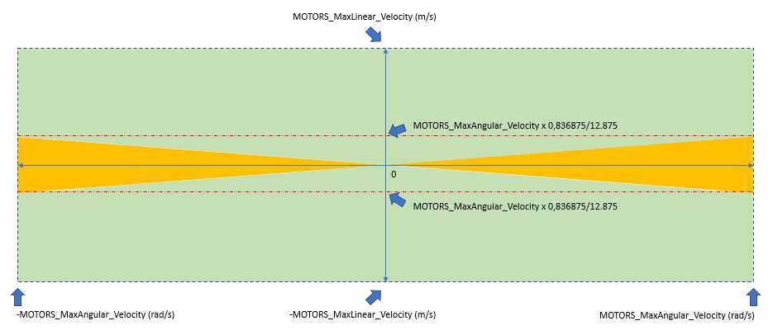

What we could see in the graph above is that there are mainly two areas:

* The green area represents normal behaviour of the robot. The top one is the behaviour of the robot when it is moving forward, with different positive values of *Linear_Velocity* and different positive and negative values of *Angular_Velocity.* Both wheels are moving in the same direction. This is a case where R > L/2.
* The orange area represents combinations of both values that would cause one wheel to move in opposite direction to the other or just stop while the other is moving. This is a case where R <= L/2. As a result, the centre of rotation (ICR) would be somewhere in the line that goes from the centre of one wheel to the centre of the other wheel, where T is. In this area the friction on the wheels may be stronger.

#### Motors PID control

A timer interrupt calls the function *ISR(TIMER1_OVF_vect)* every *PID_Interrupt_ms* milliseconds. This function basically does the following:

* Get the value of *Motor1_feedback* and *Motor2_feedback* as the encoders count and reset them to zero.
* Run two independent PID controls for both motors, one after the other getting *Motor1_PWM* and *Motor2_PWM*, that are the duty cycles of the PWM signals
* Apply a small limits filter
* Send the PWM values to the motors

Figure below shows how the PID control loop is implemented for one of the Motors (Motor1). It is the same concept for the other motor.

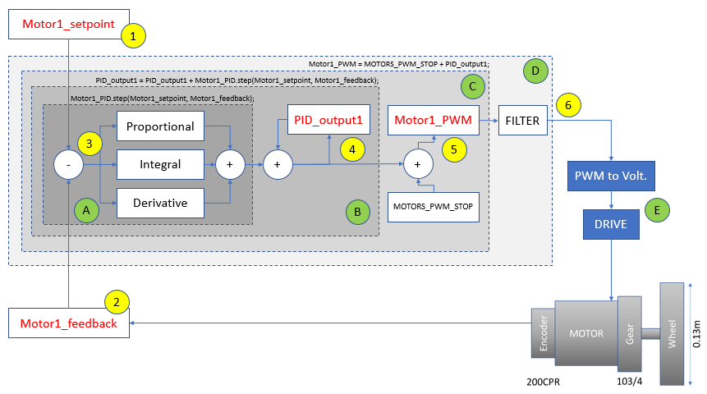

Figure 3. PID for speed of Motor1 (right motor) forward.

Basically, the PID loop gets two values as inputs:

* (1) A Setpoint value (Motor1_setpoint) that is generated by the function *SetMotorsVelocity* explained above. This value represents the desired speed of the motor.
* (2) The speed feedback from encoder (Motor1_feedback)

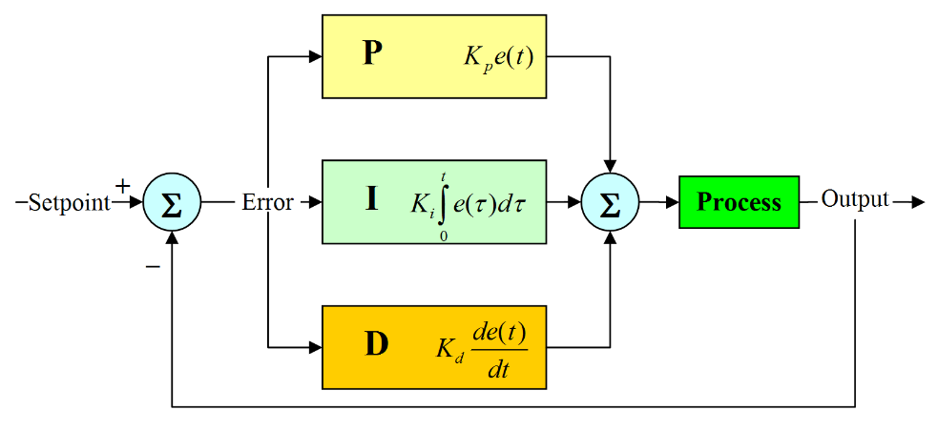These values are transferred to the function *Motor1_PID.step(Motor1_setpoint, Motor1_feedback)* that runs one iteration of the PID calculations (inner dark grey rectangle in above figure) (A)

Inside this function call, both values are subtracted to get the difference between the value we want (setpoint) and the value we get (feedback) and this subtraction is called “Error” (3). This value feeds the Proportional, Integral and Derivative components of the PID getting an increment value PID_output1. Thus, the result of the medium grey rectangle (B) in above picture is as follows (4):

|  |
| --- |
| *PID_output1 = PID_output1 + Motor1_PID.step(Motor1_setpoint, Motor1_feedback)*  *PID_output2 = PID_output2 + Motor2_PID.step(Motor2_setpoint, Motor2_feedback);* |

The PWM output for our application could go from 0 to 255, but with a particular circumstance due to the way the Hardware parts, Volt + Driver module (E) works:

* Motor stops when PWM duty is in the middle of the full range. We set *MOTORS_PWM_STOP* in a pre-processor directive as 127.
* Motors moves forward in the range from *MOTORS_PWM_STOP+1* to 255. Being 255 the maximum forward speed
* Motors moves backwards in the range from 0 to *MOTORS_PWM_STOP-1*. Being 0 the maximum backwards speed

In order to ensure correct output values in these ranges, we set the PID to work in the range (-MOTORS_PWM_STOP … +MOTORS_PWM_STOP)

|  |
| --- |
| Motor1_PID.setOutputRange(-MOTORS_PWM_STOP, MOTORS_PWM_STOP);  Motor2_PID.setOutputRange(-MOTORS_PWM_STOP, MOTORS_PWM_STOP); |

The PID loop will start on 0, but the output should correspond to MOTORS_PWM_STOP, so we add MOTORS_PWM_STOP to the output, getting in (C) a real output of between 0 and 2* MOTORS_PWM_STOP (254) (5):

|  |
| --- |
| Motor1_PWM = MOTORS_PWM_STOP + PID_output1;  Motor2_PWM = MOTORS_PWM_STOP + PID_output2; |

Finally, in (D) we apply a filter that prevents motors moving in the opposite direction than they should due to overshoots in the PID near stop point and send de PWM values (6):

|  |
| --- |
| analogWrite(PIN_MOTOR1_PWM, Motor1_PWM);  analogWrite(PIN_MOTOR2_PWM, Motor2_PWM); |

The PID Gains are defined via the float variables Kp1, Ki1, Kd1 for Motor1 and Kp2, Ki2, Kd2 for Motor2. There is a lot of documentation about PID gains calculations, so it will not be discussed in more detail here.

Libraries used

For encoders reading and PID control, the following libraries have been used

#include <Encoder.h> //Encoder library <https://www.pjrc.com/teensy/td_libs_Encoder.html>

#include <FastPID.h> // PID library <https://github.com/mike-matera/FastPID>

The PID Cycle time

As mentioned *PID_Interrupt_ms* (defined at the beginning of the program as a pre-processor directive) sets the time between encoders reading and PID loop cycle. This value should be low enough to activate rapidly to changes in the inputs but slow enough to give time for the inputs to change.

Following graph shows a direct increase (with no PID) in the PWM duty applied to the one motor (orange) and the resulting speed measured by encoder (blue). As we could see, there is a delay between the action (Pwm) and reaction (feedback). The cycle of the PID should allow for this reaction to happen. If the cycle is too short, the PID will over react as no changes would happen during a while.

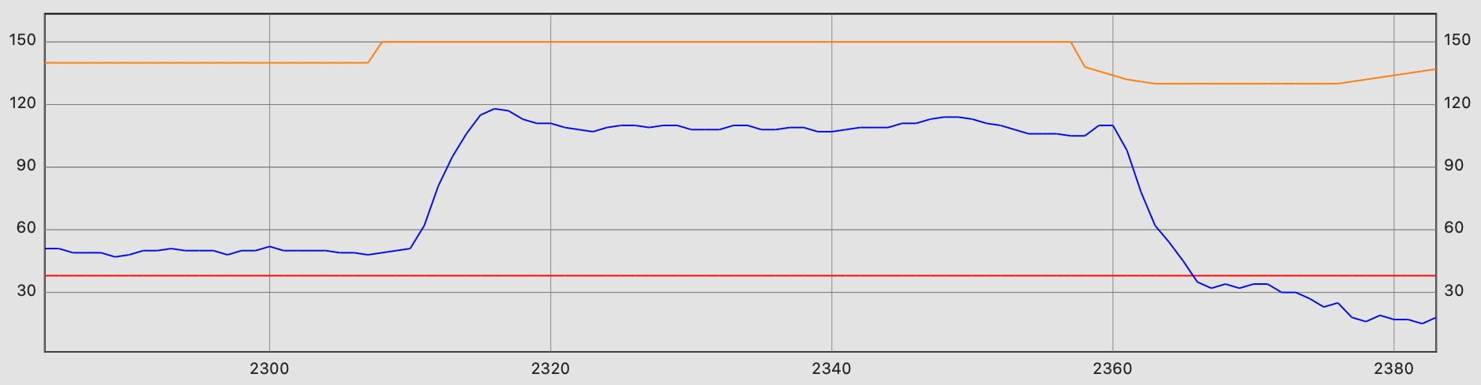

This delay is normal in any physical system. Measuring it is key. In our case we get that reaction starts to happen after 50ms and fully happen after 150ms. Therefore *PID_Interrupt_ms* should be between both values. Something about 70, that is in the middle could be ok, so the PID is not too slow or too fast.

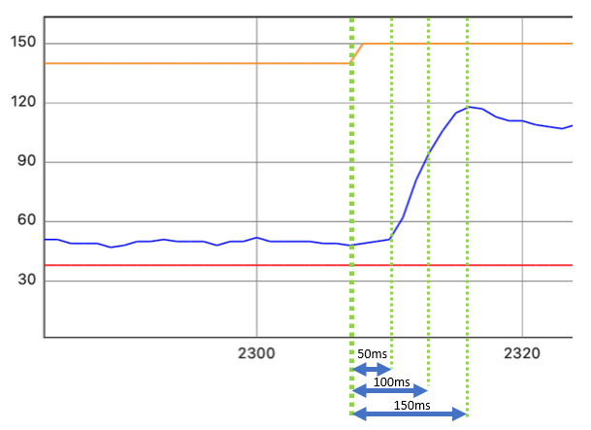

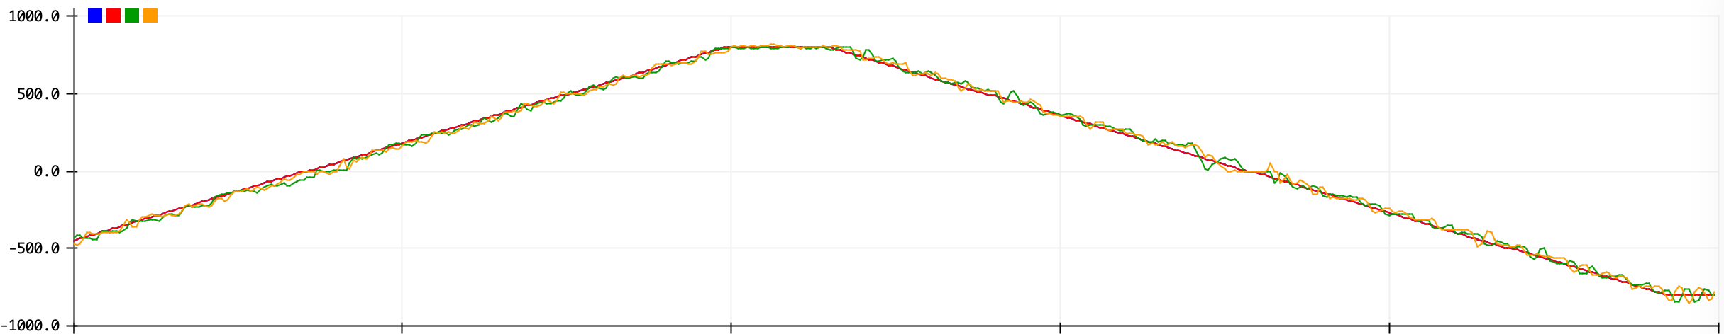

Ilustración 1. PID_Interrupt_ms = 70ms and linear velocity varying from -1m/s to 1m/s and back again.

### RFID interrogator

The use of the interrogator in this application is very straightforward. Simply the serial TX (Aux interface) sends information at 57.600bps on the tag read to the Low-Level Control System. It sends the data in RS232 format with bits inverted, so additional electronics are used to convert to TTL levels for the serial port of the Low-Level Control System. This is described in the previous chapter about Hardware Design.

There is a function in the program called *RFID_Actions()* responsible of checking the data received form the RFID interrogator and acting depending on the data received. So far there are some actions defined for specific RFID values inside this function. These values are defined at the beginning of the program:

//RFID Tags

#define RFID_ACTION_PINHOOK_UP 1

#define RFID_ACTION_PINHOOK_DWN 2

#define RFID_ACTION_FAST_SPEED 3

#define RFID_ACTION_SLOW_SPEED 4

#define RFID_ACTION_ROTATE180 5

struct tag_and_actions

{

String tag;

byte action;

String description;

};

tag_and_actions RFID_tag [] = { {"1D05", RFID_ACTION_PINHOOK_UP ,"Pinhook UP" },

{"E140", RFID_ACTION_PINHOOK_DWN ,"Pinhook DW"},

{"416C", RFID_ACTION_FAST_SPEED ,"Fast Speed" },

{"1D04", RFID_ACTION_SLOW_SPEED ,"Slow Speed" },

{"48A8", RFID_ACTION_ROTATE180 ,"Rotate 180" }};

tag_and_actions RFID_read; //RFID tag read

### Magnetic guidance

The magnetic guidance is based on the data read by the Magnetic Band Sensor.

As described in the Hardware Design section, the sensor has four signals:

* **Gate OUT**: Digital output. Negative Logic. Detection of band. If detected: LOW, if not detected: HIGH
* **Deviation OUT**: Analog output. Range depending on the position of the magnetic band.
* **Sel1 IN**, **Sel2 IN**: Digital input. Selection of working mode.

Setting the bits of SEL1IN and Sel2IN we configure the way the sensor works (Se HW Design section). This is done in the program via the function *SetMagMode(byte mag_mode)*

There is a global boolean variable (*MagGuidance_Active*) that allows the AMR to activate the magnetic guidance or not. If that variable in True, in every cycle of the main loop, the function *MagGuidance()* is called. The magnetic guidance is executed inside this function to make the AMR follow the band. The process controls the behaviour by adjusting the Global_angular_velocity of the robot and will go at a specified Global_linear_velocity.

### Pinhook control

The Pinhook control is very straightforward. It is controlled by the function *PinHook (byte command)* with the parameter “*UP*” or “*DOWN*”. The linear actuator has an auto-stop system when limits (UP or DOWN) are reached, so there is no control.

There is a reed sensor to detect when the Pinhook is up (See HW Design section) but it is not functional.

### Rearm Button

So far there is just code to detect the status of the button and activate the led in the button as feedback, but there is no action associated to it.

This is the only code available in the main loop of the program:

//General Purpose button at the back of the AMR

if (digitalRead(PIN_BUTTON)==true) digitalWrite(PIN_BUTTON_LED, HIGH); //If button is pressed, switch on its led

else digitalWrite(PIN_BUTTON_LED, LOW); //Otherwise, switch it off

### Sound signals

Sound signals are produced in the LLC by a buzzer. To activate it, the tone function *tone (pin, frequency, duration)* from Arduino language is used.

The purpose of this signals are:

* Produce a nice ‘Music’ at the beginning of the program, by using the *Pitches* library (<https://www.arduino.cc/en/Tutorial/BuiltInExamples/toneMelody>)
* Produce beeps when needed to confirm anything, like keypad pushes
* Produce beeps when safety stop condition is active and other lidar conditions (pending to implement)

### Lidar and Safety

There are several functions related to Lidar and safety functionalities:

* ***GetLidarStatus ()***: Returns status of Lidar in a byte, being b0 the warning field status, b1 the protective field and b2 the dirty signal
* ***ResetLidar ()***: Sends a pulse for resetting Lidar
* ***SetLidarCase(byte cases)***: Set Lidar Cases (0:Short case, 1:Long case, 2:Park mode, 3:No detection) through the safety PLC
* ***digitalRead(PIN_SAFETYSTOP)***: Return if the safety stop is active at the safety PLC level.
* ***digitalWrite(PIN_MOTORS_ACTIVE, false/true)***: If it is false, it asks the safety PLC to produce a pseudo-safety stop. If is true it release the Safety PLC from this pseudo-safety stop, but if there are other conditions that makes the Safety PLC to be in Safety Stop mode, then this signal will not release from this condition (Lidar protective field compromised, safety stop button activated,..)
* **Buzzer_warnings()**: Implement Buzzer sounds depending on the warning condition: 2Hz beeping if Protective field is compromised, 1Hz beeping if warning field is compromised and 1 bip every 4 second if safety stop button (local or remote) is active. No warning is done in the first 20 seconds of a boot-up because Lidar takes that time to be ready.

### LCD and keypad

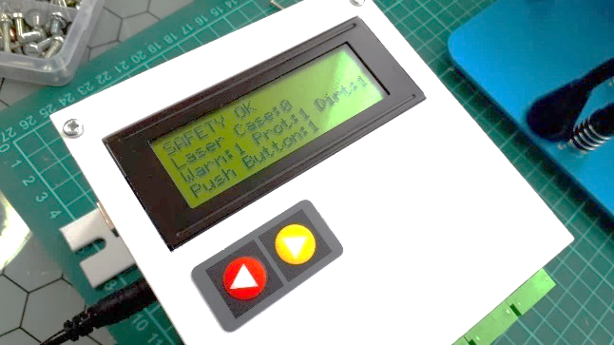As described in HW Design section, it is used a 20x4 LCD display. It is used to show several internal values of the system. These values are grouped in “Screens” and a two key membrane keypad is used to move from one screen to the next or previous one.

The LCD is controlled via I2C by using the LCD03 library.

* Link to the product page: <https://www.robot-electronics.co.uk/htm/Lcd03tech.htm>
* Link to the LCD03 library: <https://github.com/andatche/arduino-lcd03>

The function that shows the different screens is *LCDShow (byte screen_num)*

The screens content is as follows:

* Screen 0: LLC Software version, time LLC on
* Screen 1: Motors related values: PID gains
* Screen 2: Motors related values: Set Point, encoders feedback, pwm generated
* Screen 3: Safety related values: Safety status, Laser Case, Warning, Protective, Laser dirty, rearm button
* Screen 4: Magnetic guidance related values: Band detection, mag. sensor mode, mag. value, RFID tag and action

As mentioned, moving from one screen to the other is done based on keypad actions. The library used is <https://playground.arduino.cc/Code/Keypad/>

In the loop section of the program is the snippet of code that checks the keypad and refresh the LCD values:

//LCD display loop

LCD_t2 = millis();

if (LCD_t2 - LCD_t1 > LCD_t_interval) {

LCD_t1 = LCD_t2;

//Move from one LCD screen to other based on keypad push

if ((KbdKey == '<') and (LCD_Scr_Num > 0)) LCD_Scr_Num = LCD_Scr_Num-1;

if ((KbdKey == '>') and (LCD_Scr_Num < LCD_Max_Scr_Num)) LCD_Scr_Num = LCD_Scr_Num+1;

KbdKey = '.';

LCDShow (LCD_Scr_Num);

}

}

### External commands from PC

Note: This has been disabled since v0.6 of the program due to conflict with ROS integration. Anyway, if needed, could be implemented via topics.

The LLC program includes a call in the loop section to the function *CheckExternalCmds()*. This function allows connecting a PC to the LLC external serial port (9600,8,n,1) and send keystrokes via the Arduino serial monitor tool or any other terminal emulator. It is used mainly for testing during development, including actions like the following:

* 's': Stop
* 'q': Forward speed increase by 0.1m/s
* 'a': Backwards speed decrease by -0.1m/s
* 'o': Decrease angular speed by 0.1r/s (tend to turn to the left)
* 'p': Increase angular speed by 0.1r/s (tend to turn to the right)
* 's': Stop by direct action the safety PLC (pseudo safety stop)
* '0': Stop but by speed control
* '2': Set fwd speed to 0.2m/s
* '3': Set fwd speed to 0.3m/s
* '4': Set fwd speed to 0.4m/s
* '5': Set fwd speed to 0.5m/s
* 'm': Magnetic guidance activation
* 'n': Magnetic guidance deactivation

### LLC ROS Integration

*Low-Level Control System* integrates rosserial to communicate with the *High-Level Control System* using Ros messaging. Working since v0.29 of the LLC program.

Tutorial here: <http://wiki.ros.org/rosserial_arduino/Tutorials>

rosserial provides a ROS communication protocol that works over Arduino's UART. It allows Arduino to be a full-fledged ROS node which can directly publish and subscribe to ROS messages, publish TF transforms, and get the ROS system time.

The libraries version installed is 0.7.9. rosserial library: <https://github.com/frankjoshua/rosserial_arduino_lib>

We publish every second the following topics:

* velocity_lin
* velocity_ang
* safety_status (*Bit0..1: Lidar Case, Bit2: Lidar warning, Bit3: Lidar protective, Bit4: Lidar dirty, Bit5: Safety stop, Bit6: Button pressed, Bit7..15: Not used*)
* rfid_tag

In the Arduino code of LLC it is included the following code:

At the declaration section:

|  |
| --- |
| *//ROS integration*  *#include <ros.h> //rosserial library https://github.com/frankjoshua/rosserial_arduino_lib*  *#include <std_msgs/String.h>*  *#include <std_msgs/Float32.h>*  *#include <std_msgs/UInt16.h>*  *ros::NodeHandle nh;*  *std_msgs::Float32 velocity_lin_msg;*  *std_msgs::Float32 velocity_ang_msg;*  *std_msgs::UInt16 safety_status_msg;*  *std_msgs::String rfid_tag_msg;*  *ros::Publisher pub_velocity_lin("**velocity_lin", &velocity_lin_msg);*  *ros::Publisher pub_velocity_ang("**velocity_ang", &velocity_ang_msg);*  *ros::Publisher pub_safety_status("**safety_status", &safety_status_msg);*  *ros::Publisher pub_rfid_tag("**rfid_tag", &rfid_tag_msg);*  *char rfidcode[5] = " ";* |

In the SetUp section:

|  |
| --- |
| *//ROS integration*  *nh.initNode();*  *nh.advertise(chatter);*  *nh.advertise(pub_velocity_lin);*  *nh.advertise(pub_velocity_ang);*  *nh.advertise(pub_safety_status);*  *nh.advertise(pub_rfid_tag);* |

In the Loop section:

|  |
| --- |
| *//ROS integration*  *ROSpub_t2 = millis();*  *if (ROSpub_t2 - ROSpub_t1 > ROSpub_t_interval) {*  *ROSpub_t1 = ROSpub_t2;*    *str_msg.data = hello;*  *chatter.publish( &str_msg );*    *//Velocity messages*  *velocity_lin_msg.data = Global_Linear_Velocity;*  *velocity_ang_msg.data = Global_Angular_Velocity;*  *pub_velocity_lin.publish( &velocity_lin_msg );*  *pub_velocity_ang.publish( &velocity_ang_msg );*  *//Safety message*  *safety_status_msg.data = 0;*  *if (bitRead(LidarCase, 0)) bitSet(safety_status_msg.data,0); //Lidar case*  *if (bitRead(LidarCase, 1)) bitSet(safety_status_msg.data,1); //Lidar case*  *if (not digitalRead(PIN_LIDAR_WARNING)) bitSet(safety_status_msg.data,2); //Lidar warning*  *if (not digitalRead(PIN_LIDAR_PROTECT)) bitSet(safety_status_msg.data,3); //Lidar protective*  *if (not digitalRead(PIN_LIDAR_DIRTY)) bitSet(safety_status_msg.data,4); //Lidar dirty*  *if (digitalRead(PIN_SAFETYSTOP)) bitSet(safety_status_msg.data,5); //Safety stop (from Safety PLC)*  *if (digitalRead(PIN_BUTTON)) bitSet(safety_status_msg.data,6); //Button pressed*  *pub_safety_status.publish( &safety_status_msg );*    *//RFID message*  *strcpy(rfidcode, RFID_read.tag.c_str()); // copying the contents of the string to char array*  *rfid_tag_msg.data = rfidcode; //Last RFID value read*  *pub_rfid_tag.publish( &rfid_tag_msg );*    *nh.spinOnce();*  *}* |

Nota: Hay notas importantes en el cuaderno verde de anillas a partir de la página 45

Control de motores un poco raro, pero puede servir como ejemplo ya que incorpora ROS: <https://github.com/zoubworldArduino/ZcmdMotor>

## High-Level Controller (HLC)

As High-Level Control System a Raspberry Pi 3B+ is used.

Operating System, Ros description…

### HLC Cloud monitoring connection

To provide Cloud Monitoring, based on AWS, the HLC will keep an MQTT link based on AWS IOT, so AWS IOT works as MQTT broker and server and HLC will works as client.

The steps to follow are:

1. Download the connection kit for Linux on RPi  
   git clone https://github.com/aws/aws-iot-device-sdk-python
2. I go to the directory where start.sh is and run   
    chmod +x start.sh

./start.sh

it starts installing everything and runs a publisher/subscriber that I test and works well in both directions. CTRL+C to stop

1. following step by step what is described in this video: https://www.youtube.com/watch?v=kPLafcrng-c
2. Create a thing: amr_one_001
3. Create certificates and download
4. move certificates to RPi
5. Create Policy: amr_one_policy
6. Link thing, certificate, and policy
7. Create Cognito and link to thing
8. Prepare python program. Got ideas from <https://techblog.calvinboey.com/raspberrypi-aws-iot-python/>
9. Run the program (python3 <program>)
10. Monitor the results from IoTCore. Test page. To see that the messages comes.

See <https://automacomp.atlassian.net/browse/AMR-235> for more details

The program is as follows:

'''/*

2 * Program to send data to AWS IoT Core

3 * by: Alejandro Alonso

4 * April 2022

5 */'''

6

7**from** AWSIoTPythonSDK.MQTTLib **import** AWSIoTMQTTClient

8**from** time **import** sleep

9**from** datetime **import** date, datetime

10

11*# AWS IoT certificate based connection*

12myMQTTClient = AWSIoTMQTTClient("amr_one_001") *#random key, if another connection using the same key is opened the previous one is auto closed by AWS IOT*

13myMQTTClient.configureEndpoint("ays0km0xaon9v-ats.iot.eu-central-1.amazonaws.com", 8883)

14

15myMQTTClient.configureCredentials(

16 "/home/turtlebot/catkin_ws/src/amr_one_hlc/AWSIoT/AmazonRootCA1.pem",

17 "/home/turtlebot/catkin_ws/src/amr_one_hlc/AWSIoT/amr_one_001-private.pem.key",

18 "/home/turtlebot/catkin_ws/src/amr_one_hlc/AWSIoT/amr_one_001-certificate.pem.crt")

19

20myMQTTClient.configureOfflinePublishQueueing(-1) *# Infinite offline Publish queueing*

21myMQTTClient.configureDrainingFrequency(2) *# Draining: 2 Hz*

22myMQTTClient.configureConnectDisconnectTimeout(10) *# 10 sec*

23myMQTTClient.configureMQTTOperationTimeout(5) *# 5 sec*

24**print** ('*********** Initiating Data Transfer From Raspberry Pi...')

25

26*#connect and publish*

27myMQTTClient.connect()

28**print** ('*********** Connected')

29*#loop and publish sensor reading*

30**while** True:

31 now = datetime.utcnow()

32 now_str = now.strftime('%Y-%m-%dT%H:%M:%SZ') *#e.g. 2016-04-18T06:12:25.877Z*

33 payload='{ "timestamp": "' + now_str + '","temperature": ' + str(4) + ',"humidity": '+ str(5.5) + ' }'

34 payload='{ "timestamp": "' + now_str + '",' + '"device_num": ' + '"amr_one_001"' + ',' + '"velocity_lin": ' + str(0.5) + ',' + '"velocity_ang": ' + str(-0.1) + ',' + '"safety_status": ' + str(45) + ',' + '"rfid_tag": ' + '"4D32"' + ',' + '"error_msg": ' + str(5.5) + ' }'

35 myMQTTClient.publish("amr_one_001/data", payload, 0)

36 sleep(1)

Getting as result:

amr_one_001/data

2April 08, 2022, 12:57:25 (UTC+0200)

3{

4 "timestamp": "2022-04-08T10:57:26Z",

5 "device_num": "amr_one_001",

6 "velocity_lin": 0.5,

7 "velocity_ang": -0.1,

8 "safety_status": 45,

9 "rfid_tag": "4D32",

10 "error_msg": 5.5

11}

### Subscriber to data for monitoring

In previous program it was sent a set of dummy data, but real data comes from a subscription to some topics that comes from LLC: See LLC ROS Integration section above. So the program have subscriptions to ROS topics and publish in MQTT. For that we included:

At the top of the program the imports needed:

import rospy #ROS integration

from std_msgs.msg import UInt16 #For ROS topics

from std_msgs.msg import Float32 #For ROS topics

from std_msgs.msg import String #For ROS topics

Initialization values of the topics:

#Initialization section

velocity_lin = 0.0 #Value read from ROS Topic and sent via MQTT topic

velocity_ang = 0.0 #Value read from ROS Topic and sent via MQTT topic

rfid_tag = " " #Value read from ROS Topic and sent via MQTT topic

safety_lidar_case = 0 #Value taken (parsed) from ROS Topic "safety_status"

safety_lidar_warning = 0 #Value taken (parsed) from ROS Topic "safety_status"

safety_lidar_protective = 0 #Value taken (parsed) from ROS Topic "safety_status"

safety_lidar_dirty = 0 #Value taken (parsed) from ROS Topic "safety_status"

safety_stop = 0 #Value taken (parsed) from ROS Topic "safety_status"

back_button = 0 #Value taken (parsed) from ROS Topic "safety_status"

Node initialization:

#ROS node initialization

rospy.init_node('ros_to_awsiot', anonymous=True) # Initiate a ROS node

Subscribers:

#Listen to ROS topics

rospy.Subscriber('velocity_lin', Float32, ros_callback_velocity_lin) # Create a subscriber object that will listen to the topic

rospy.Subscriber('velocity_ang', Float32, ros_callback_velocity_ang) # Create a subscriber object that will listen to the topic

rospy.Subscriber('safety_status', UInt16, ros_callback_safety_status) # Create a subscriber object that will listen to the topic

rospy.Subscriber('rfid_tag', String, ros_callback_rfid_tag) # Create a subscriber object that will listen to the topic

rospy.sleep(1) #Give time for the first topic to be published

Callbacks:

def parse_out_bits(bit_field, start_index, end_index):

#extract one or more bits from integer

mask = (1 << (end_index - start_index + 1)) - 1

return (bit_field >> start_index) & mask

def ros_callback_velocity_lin(msg):

# functioned called from ROS subscriber when received ROS topics.

global velocity_lin

velocity_lin = (msg.data)

def ros_callback_velocity_ang(msg):

# functioned called from ROS subscriber when received ROS topics.

global velocity_ang

velocity_ang = (msg.data)

def ros_callback_safety_status(msg):

# functioned called from ROS subscriber when received ROS topics.

global safety_lidar_case

global safety_lidar_warning

global safety_lidar_protective

global safety_lidar_dirty

global safety_stop

global back_button

safety_status = (msg.data)

safety_lidar_case = parse_out_bits(safety_status, 0, 1)

safety_lidar_warning = parse_out_bits(safety_status, 2, 2)

safety_lidar_protective = parse_out_bits(safety_status, 3, 3)

safety_lidar_dirty = parse_out_bits(safety_status, 4, 4)

safety_stop = parse_out_bits(safety_status, 5, 5)

back_button = parse_out_bits(safety_status, 6, 6)

def ros_callback_rfid_tag(msg):

# functioned called from ROS subscriber when received ROS topics.

global rfid_tag

rfid_tag = (msg.data)

Preparation of the MQTT message:

payload='{ \

"timestamp": "' + now_str + '",' \

+ '"device_num": ' + '"amr_one_001"' + ',' \

+ '"velocity_lin": ' + str(velocity_lin) + ',' \

+ '"velocity_ang": ' + str(velocity_ang) + ',' \

+ '"safety_lidar_case": ' + str(safety_lidar_case) + ',' \

+ '"safety_lidar_warning": ' + str(safety_lidar_warning) + ',' \

+ '"safety_lidar_protective": ' + str(safety_lidar_protective) + ',' \

+ '"safety_lidar_dirty": ' + str(safety_lidar_dirty) + ',' \

+ '"safety_stop": ' + str(safety_stop) + ',' \

+ '"back_button": ' + str(back_button) + ',' \

+ '"rfid_tag": "' + rfid_tag + '",' \

+ '"error_msg": ' + str(0) + ' }'

To test that everything goes well, so data is collected from ROS topics and sent to AWS IoTCore, follow steps:

1. Connect via ssh to RPi “ssh turtlebot@turtlebot.local”
2. In one terminal: roscore
3. In another terminal: rosrun rosserial_python serial_node.py /dev/ttyUSB0
4. In another terminal:  
   roscd amr_one_hlc

roslaunch amr_one_hlc ros_to_awsiot.launch

1. Go to AWS IoT Core, Test and subscribe to topic amr_one_001/data

You will get:



To consider

How to connect Sick s300 Expert to PC for ROS: <https://answers.ros.org/question/331161/how-to-connect-sick-s300-expert-to-pc-for-ros/>

# Appendix 1. Environment preparation

## SSH on HLC

Activate SSH on RPi by executing sudo service ssh start or raspi-config for permanent ssh activation

Then enter from another computer by using ssh turtlebot@turtlebot.local

Now configure SSH connections based on public keys:

First, generate public key and private key on local PC. Open a terminal and execute:

$ ssh-keygen

Press “Enter” to accept the default parameters, “id_rsa.pub” and “id_rsa”

will be generated in “~/.ssh” folder. Then copy “id_rsa.pub” to remote

computer:

$ scp ~/.ssh/id_rsa.pub turtlebot@ip_address:/home/turtlebot (“ip_addreee” is the IP address of remote computer)

After copy “id_rsa.pub” to remote computer, login on remote computer via SSH:

$ ssh turtlebot@ip_address

After login, append the content of “id_rsa.pub” to “~/.ssh/authorized_keys” on remote computer,and change the permission of “authorized_keys” file:

$ mkdir -p ~/.ssh/

$ cat id_rsa.pub >> ~/.ssh/authorized_keys

$ chmod 600 ~/.ssh/authorized_keys

Now you can login on remote computer without a password.

AUTOLOGIN

To configure the Desktop to auto-login add an autologin-user line specifying your user name to the /usr/share/lightdm/lightdm.conf.d/60-lightdm-gtk-greeter.conf file.

sudo /usr/share/lightdm/lightdm.conf.d/60-lightdm-gtk-greeter.conf

add: [SeatDefaults] greeter-session=lightdm-gtk-greeter autologin-user=turtlebot

Conf files in the /usr/share/lightdm/lightdm.conf.d/ directory are cascaded into the lightdm login manager in alpha order.

## Programming IDEs

There are two IDEs used for programming this robot:

* Arduino IDE, for programming of the LLC
* Visual Studio Code, for programming the HLC and cloud

### Arduino IDE

Arduino IDE is installed on external PC and connected to LLC via USB. The serial cable connecting LLC to HLC should be disconnected before using the one for the Arduino IDE.

### Visual Studio Code

Visual Studio Code, or VS Code, is a free, open source, developer’s text editor with a whole swathe of extensions to support coding in multiple languages and provides tools to support development.

Visual Studio Code is installed in an external PC.

#### Remote connection to HLC

One of the extensions that helps here is the Remote SSH extension, part of a pack of remote development extensions. This extension allows you to connect to a remote device over SSH, and run VS Code as if you were running on that remote device. You see the remote file system, the VS Code terminal runs on the remote device, and you access the remote device’s hardware. When you are debugging, the debug session runs on the remote device, but VS Code runs on the host machine[4].

Remote SSH needs a Raspberry Pi 3 or 4. It is not supported on older Raspberry Pis, or on Raspberry Pi Zero.

Steps:

* Ensure you have SSH configured in RPi (see section above)
* Ensure you have VS Code installed in your computer (not the RPi)
* On VS Code, install the *Remote Development* extension
* Connect VS Code to RPi: Launch the VS Code command palette using Ctrl+Shift+P on Linux or Windows, or Cmd+Shift+P on macOS. Search for and select Remote SSH: Connect current window to host (there’s also a connect to host option that will create a new window). Enter the SSH connection details, using user@host. For the host, enter the IP address of the Raspberry Pi, or the hostname. The hostname needs to end with *.local*. The first time you connect, it will validate the fingerprint to ensure you are connecting to the correct host. Select Continue from this dialog. Enter your Raspberry Pi’s password when promoted. VS Code will then install the relevant tools on the Raspberry Pi and configure the remote SSH connection.

You will now be all set up and ready to code on your Raspberry Pi. Start by opening a folder or cloning a git repository and away you go coding, debugging, and deploying your applications.

In the remote session, not all extensions you have installed locally will be available remotely. Any extensions that change the behaviour of VS Code as an application, such as themes or tools for managing cloud resources, will be available.

Things like language packs and other programming tools are not installed in the remote session, so you’ll need to re-install them. When you install these extensions, you’ll see the Install button has changed to Install in SSH:< hostname > to show it’s being installed remotely.

1. EN ISO 13855
2. S300 Safety laser scanner operating instructions. SICK AG.
3. Keyence. Safety Laser Scanner SZ Series Manual
4. [Coding on Raspberry Pi remotely with Visual Studio Code](https://www.raspberrypi.com/news/coding-on-raspberry-pi-remotely-with-visual-studio-code/)